School Name
Mathematics Test 2017
Year 10 |  | Volume and Surface Area of Other Solids | Calculator  Allowed
Skills and Knowledge Assessed:  - Solve problems involving surface area and volume of right pyramids, right cones, spheres and related composite solids (ACMMG271) |  |  | Name_________________
Section 1 Short Answer Section
Write all working and answers in the spaces provided on this test paper.

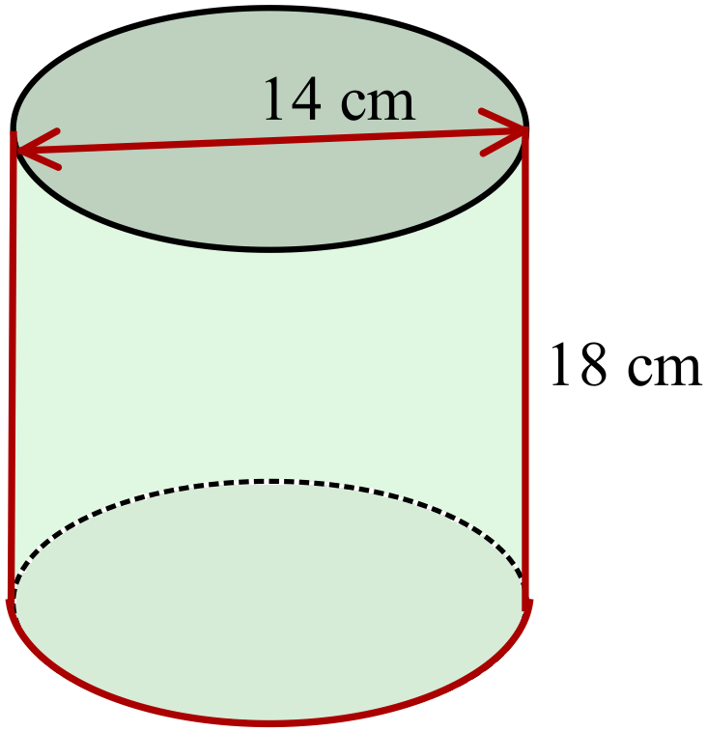Find the volume of the cylinder shown (to the nearest cm).

………………………………………………

……………………………………………....

………………………………………………

……………………………………………….
The perpendicular height of a triangular pyramid is 15 cm and its base has an area of 50 cm².
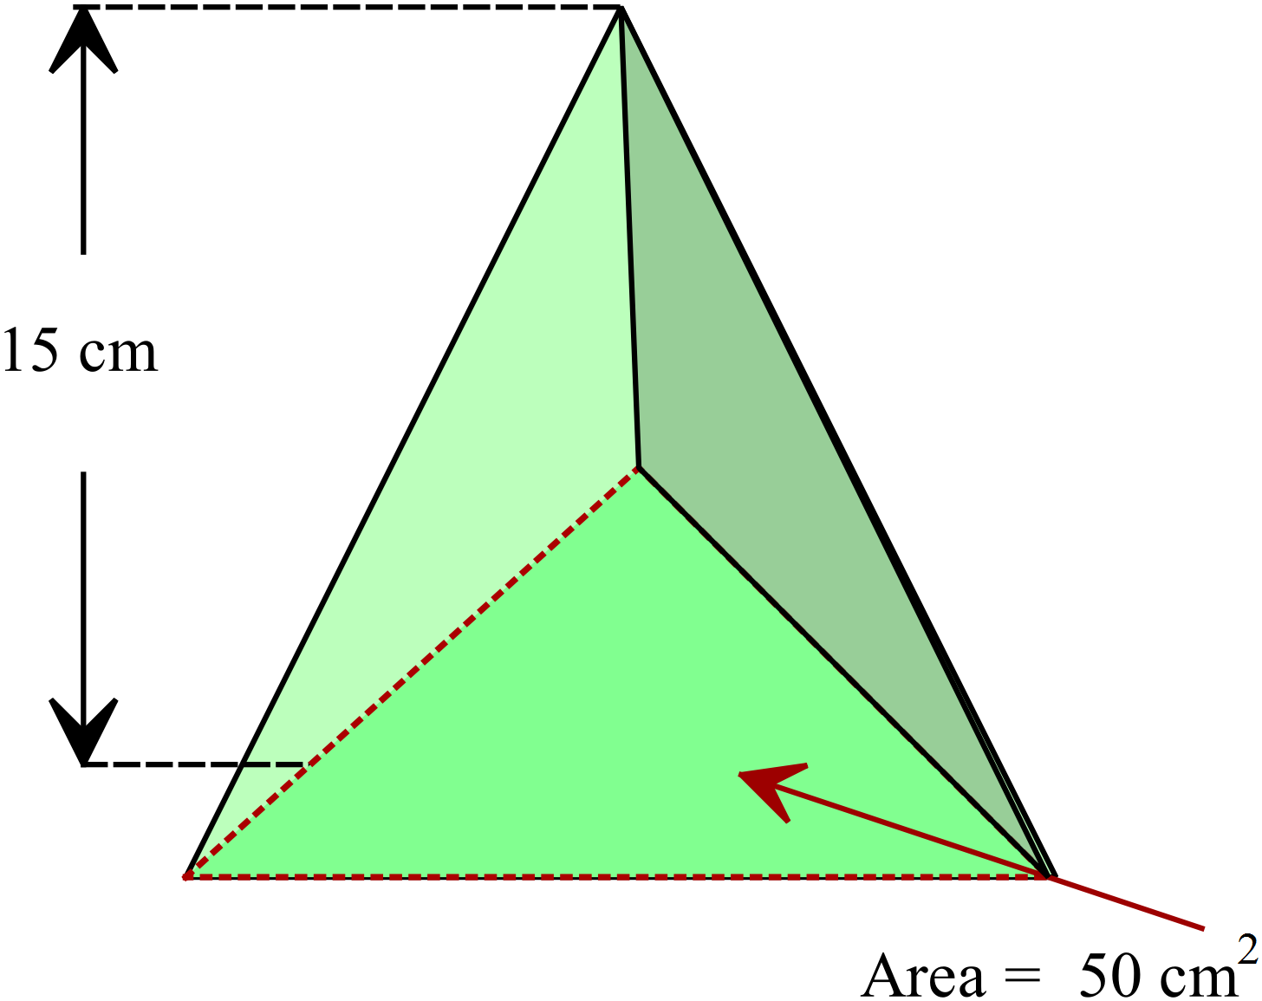What is its volume?

………………………………………………

……………………………………………....

………………………………………………

……………………………………………….

This “stepped pyramid” is made by stacking cubes which measure 2 cm along each edge.
What is the total volume of the solid formed?
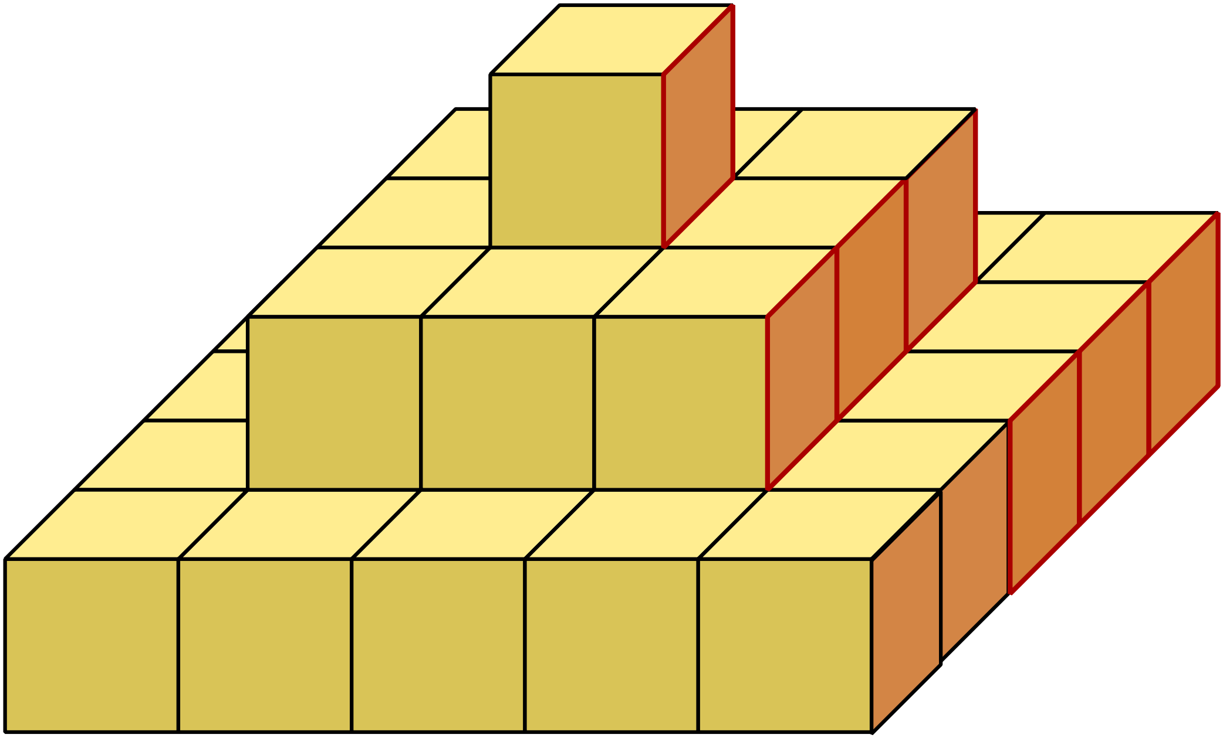

………………………………………………

……………………………………………....

………………………………………………

……………………………………………….

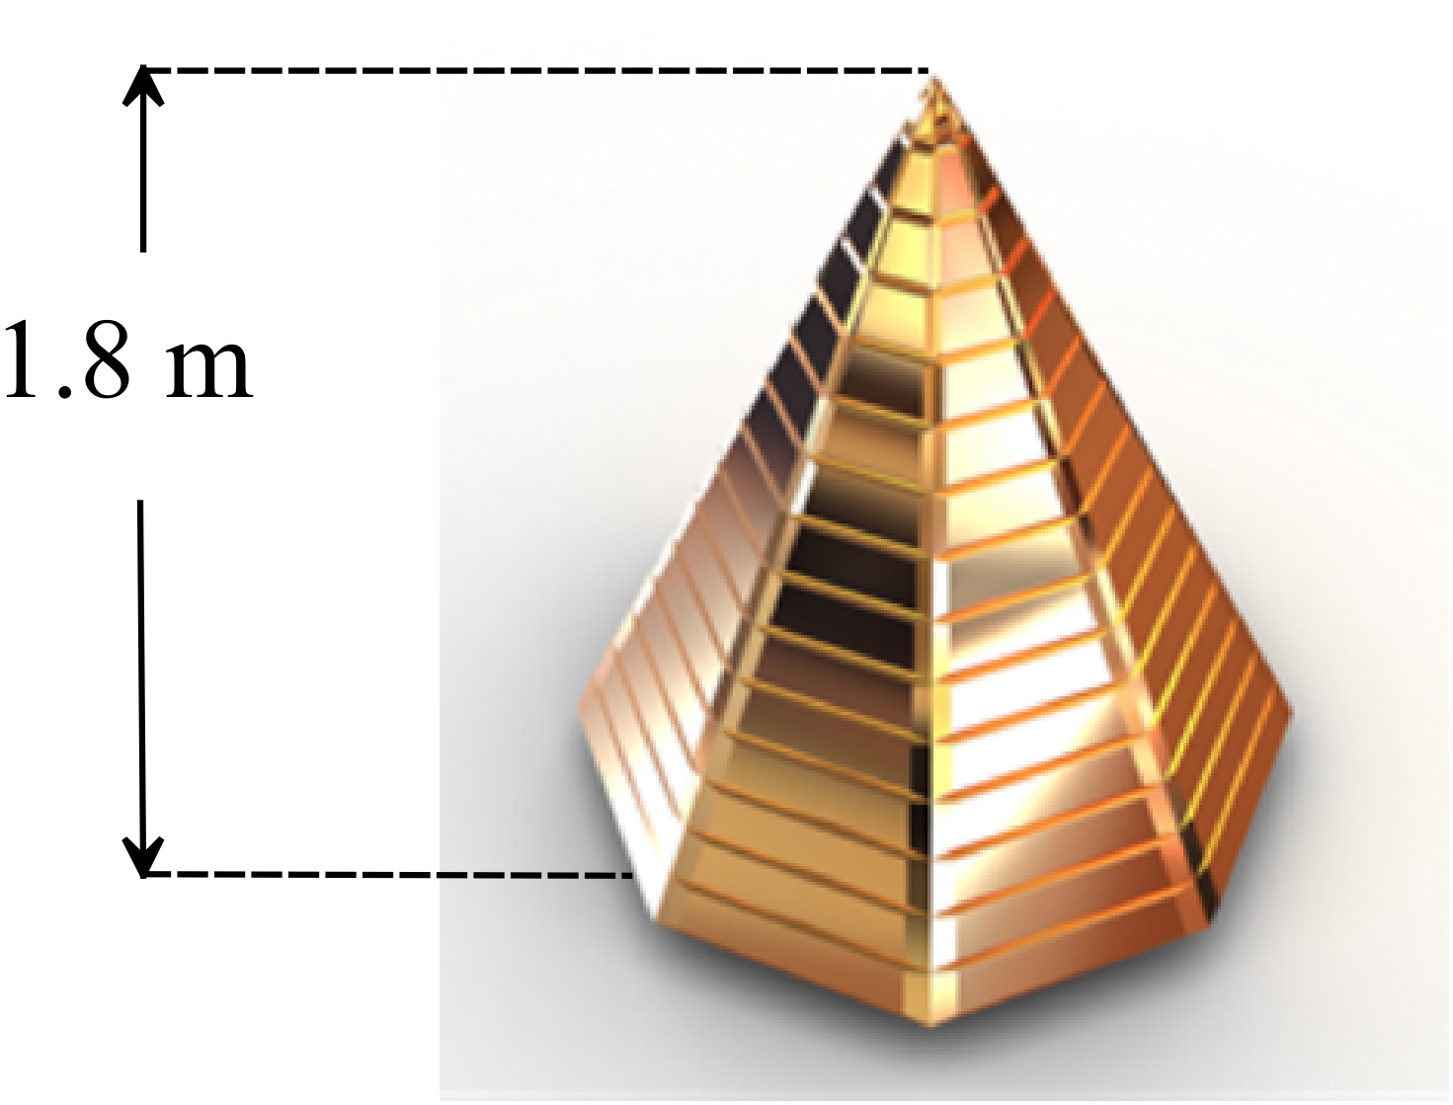A pyramid used in a movie promotion stands 1.8 m high and has a base whose area is 1.5 m².
Find its volume.

………………………………………………

……………………………………………....

………………………………………………

……………………………………………….

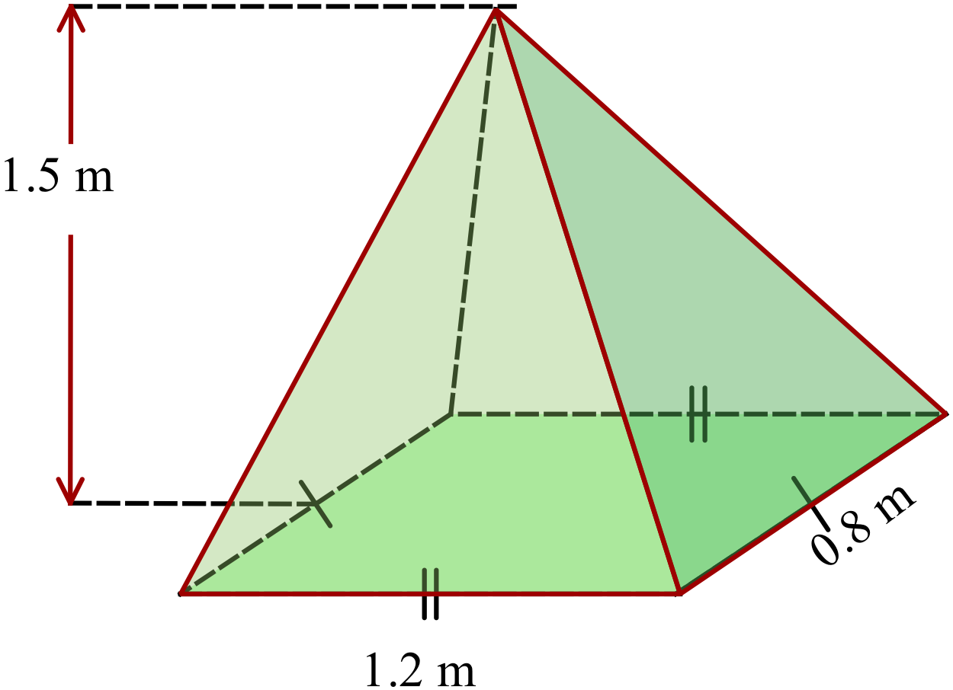What is the volume of the rectangular pyramid?

………………………………………………

……………………………………………....

………………………………………………

……………………………………………….

What is the volume of a sphere which has a radius of 1.6 metres?

……………………………………………………………………………………………….

……………………………………………………………………………………………....

……………………………………………………………………………………………….
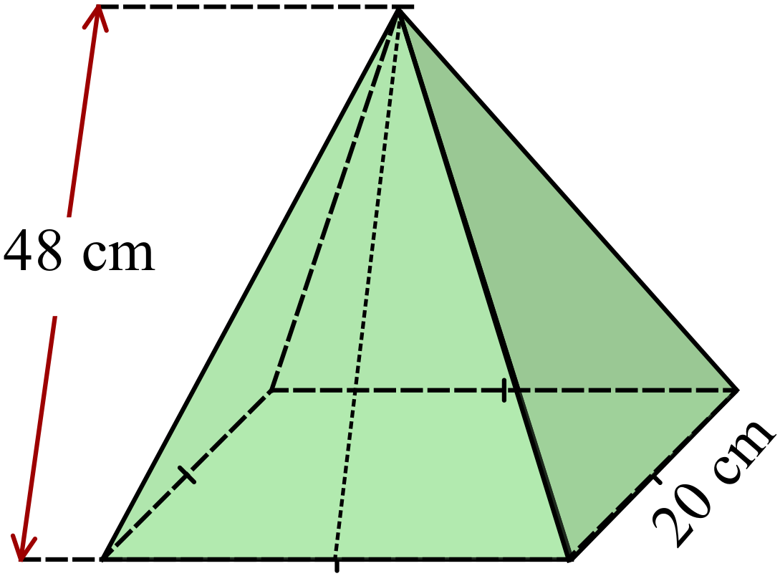What is the surface area of the square pyramid?

………………………………………………

……………………………………………....

………………………………………………

……………………………………………….
A glass sphere has a diameter of 12 cm.

What volume of glass is used in the sphere?

………………………………………………

……………………………………………....

………………………………………………

……………………………………………….
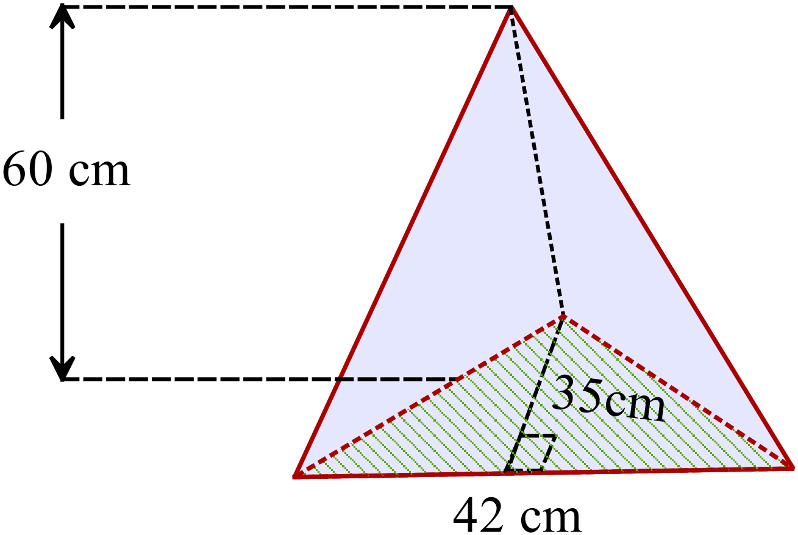Calculate the volume of the triangular pyramid shown.

………………………………………………

……………………………………………....

………………………………………………

……………………………………………….

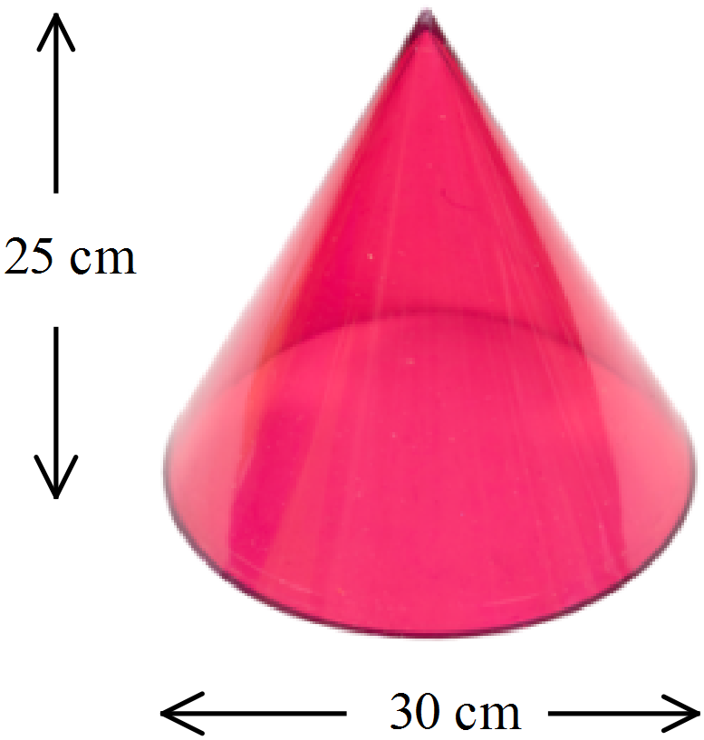What is the volume of the plastic cone shown?

………………………………………………

……………………………………………....

………………………………………………

……………………………………………….

What is the surface area of the rectangular pyramid shown?

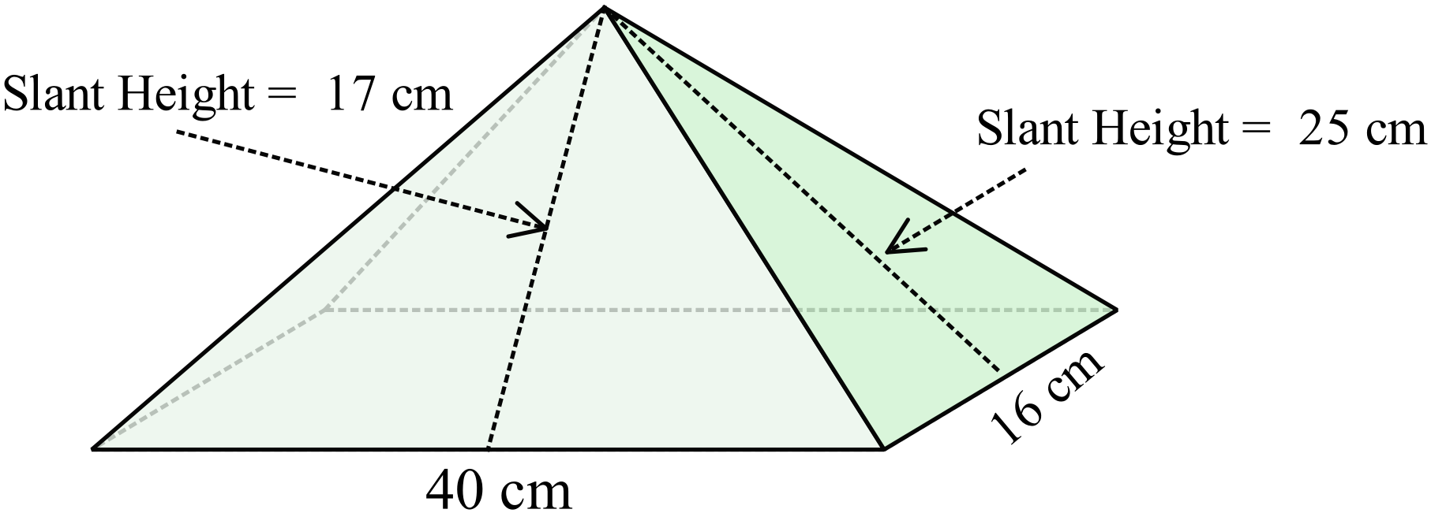

………………………………………………

……………………………………………....

………………………………………………

……………………………………………….
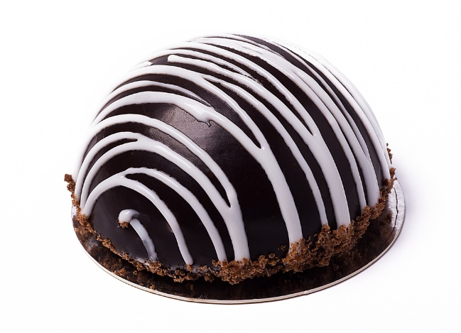
A cake is in the shape of a hemisphere with a diameter of 30 centimetres.
What is the approximate curved surface area which needs to be covered with icing?

………………………………………………

……………………………………………....

………………………………………………

……………………………………………….
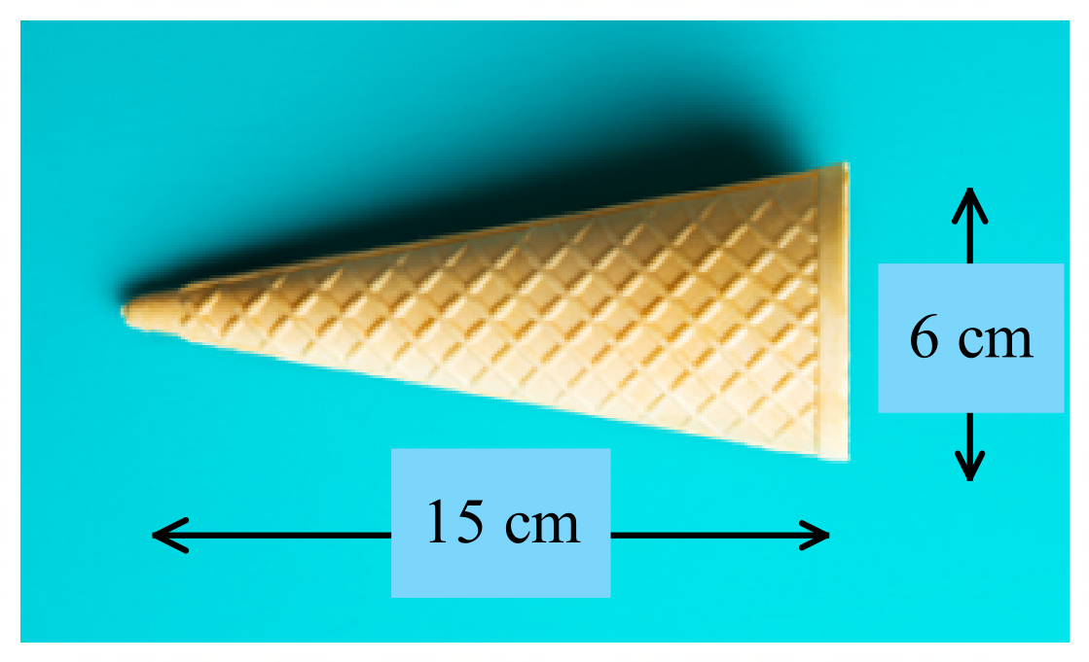A waffle cone maker produces cones of the size shown.
What is the approximate surface area of this cone?

………………………………………………

……………………………………………....

………………………………………………

……………………………………………….
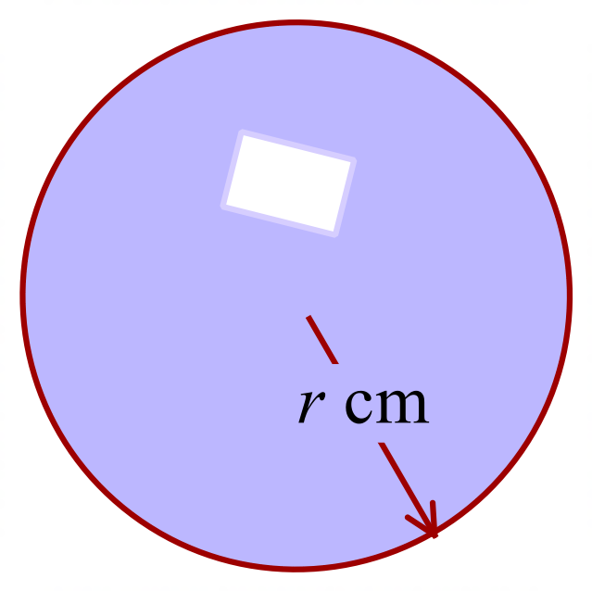A sphere has a volume of 17 157 cm³.
What is its radius, to the nearest cm?

………………………………………………

……………………………………………....

………………………………………………

……………………………………………….
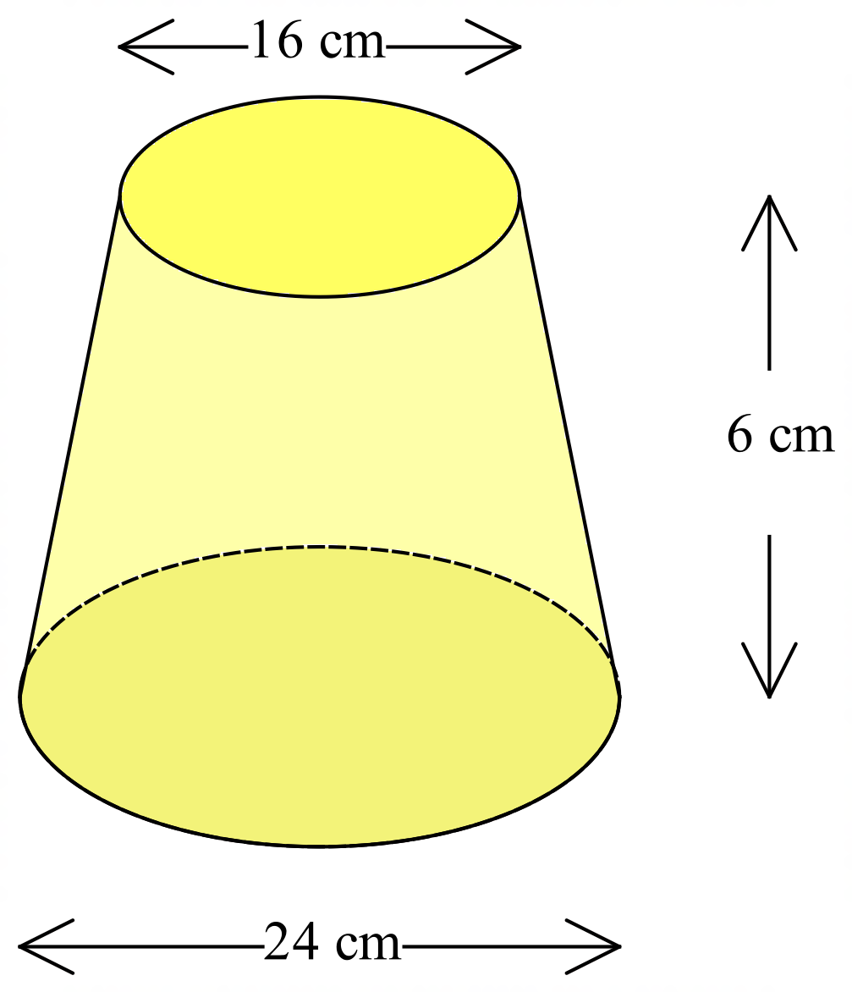The truncated cone shown is formed by cutting the top 12 cm in height from a cone which was originally 18 cm high.
The diameter of the circular base is 24 cm and of the top is 16 cm.
What is the volume of the truncated cone?

………………………………………………

……………………………………………....

………………………………………………

……………………………………………….

School Name
Mathematics Test 2017
Year 10 |  | Volume and Surface Area of Other Solids | Calculator Allowed
 |  | Volume and Surface Area of Other Solids | Name_________________
Section 2 Multiple Choice Section
Mark all your answers on the accompanying multiple choice answer sheet, not on this test paper. You may do any working out on this test paper. Calculators are allowed for this section.

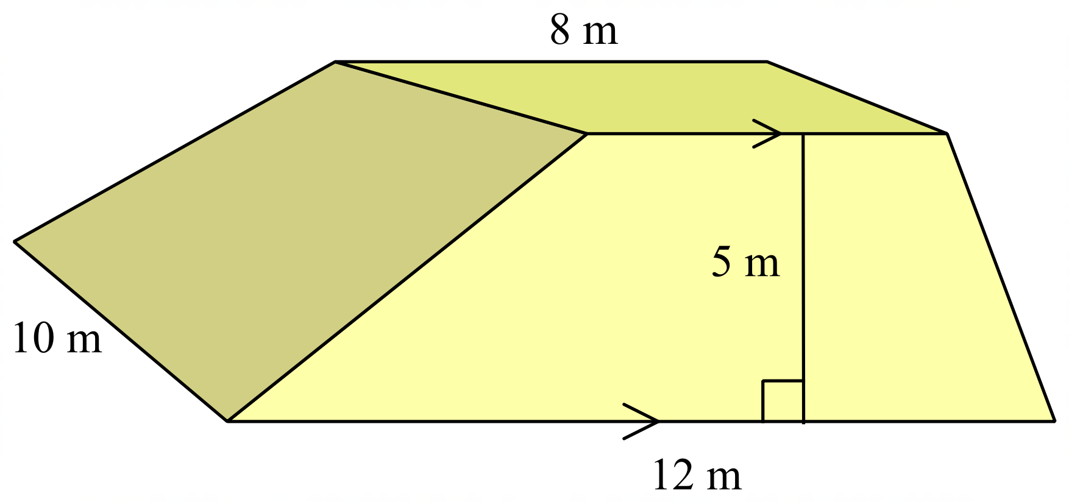What is the volume of the prism shown?

A. 250 m³
B. 400 m³
C. 500 m³
D. 600 m³

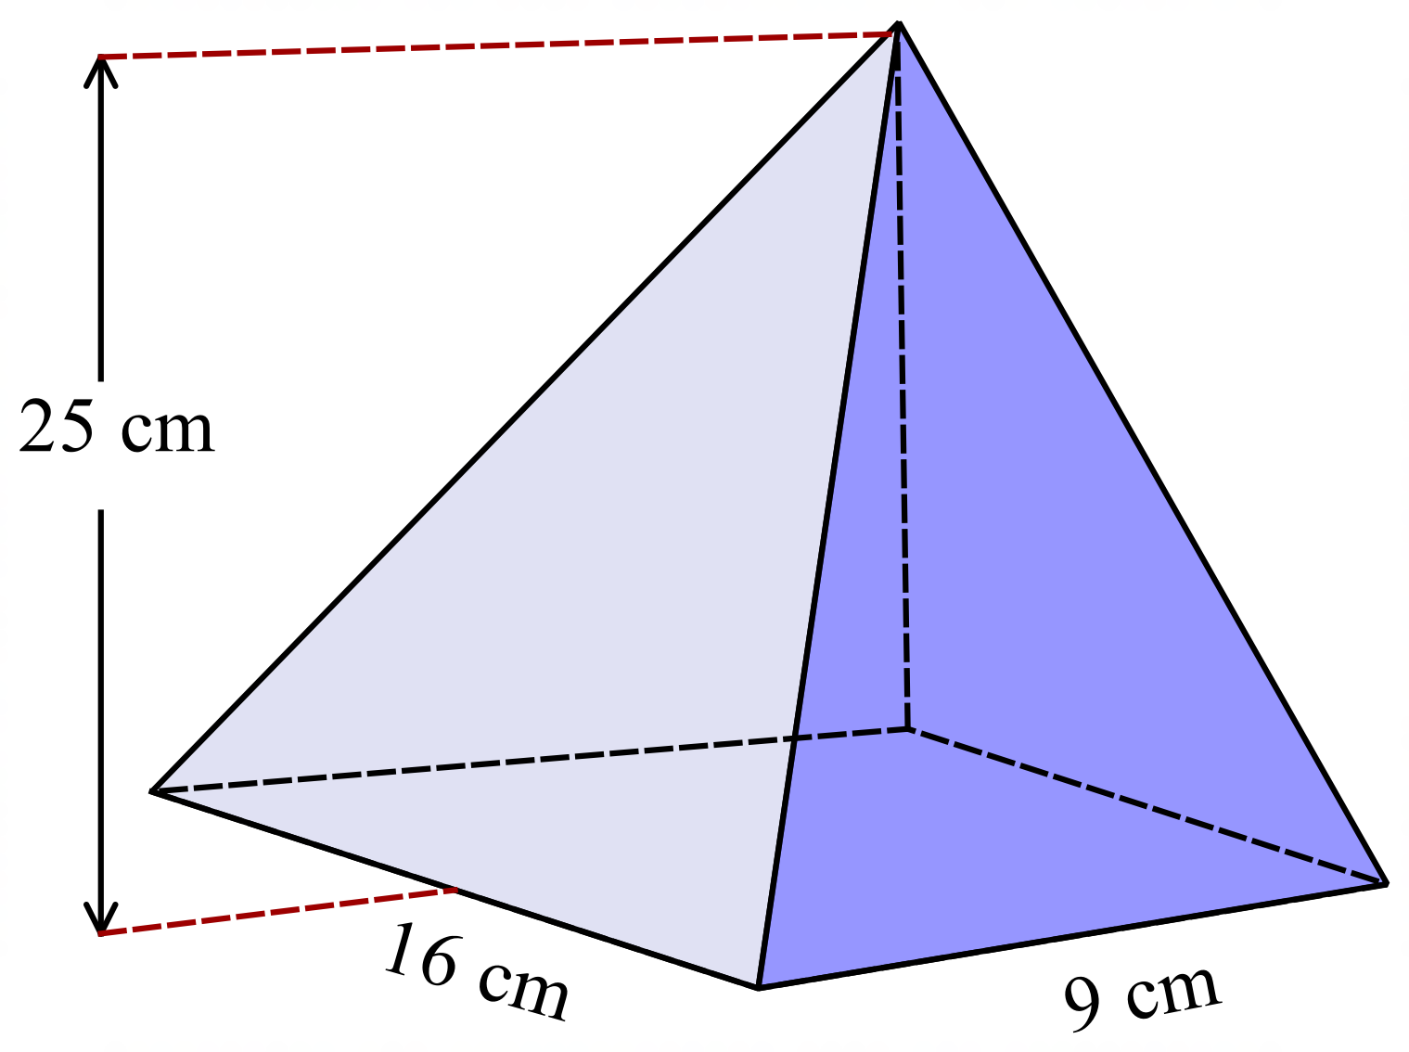Find the volume of this rectangular pyramid.

A. 1200 cm³
B. 1800 cm³
C. 2400 cm³
D. 3600 cm³

A square pyramid has base edges 2.5 m and a perpendicular of height 12 m.
What is its volume?

A. 12.5 m³ B. 25 m³ C. 37.5 m³ D. 75 m³
A cone has a height of 20 cm and the area of its base is 150 cm².
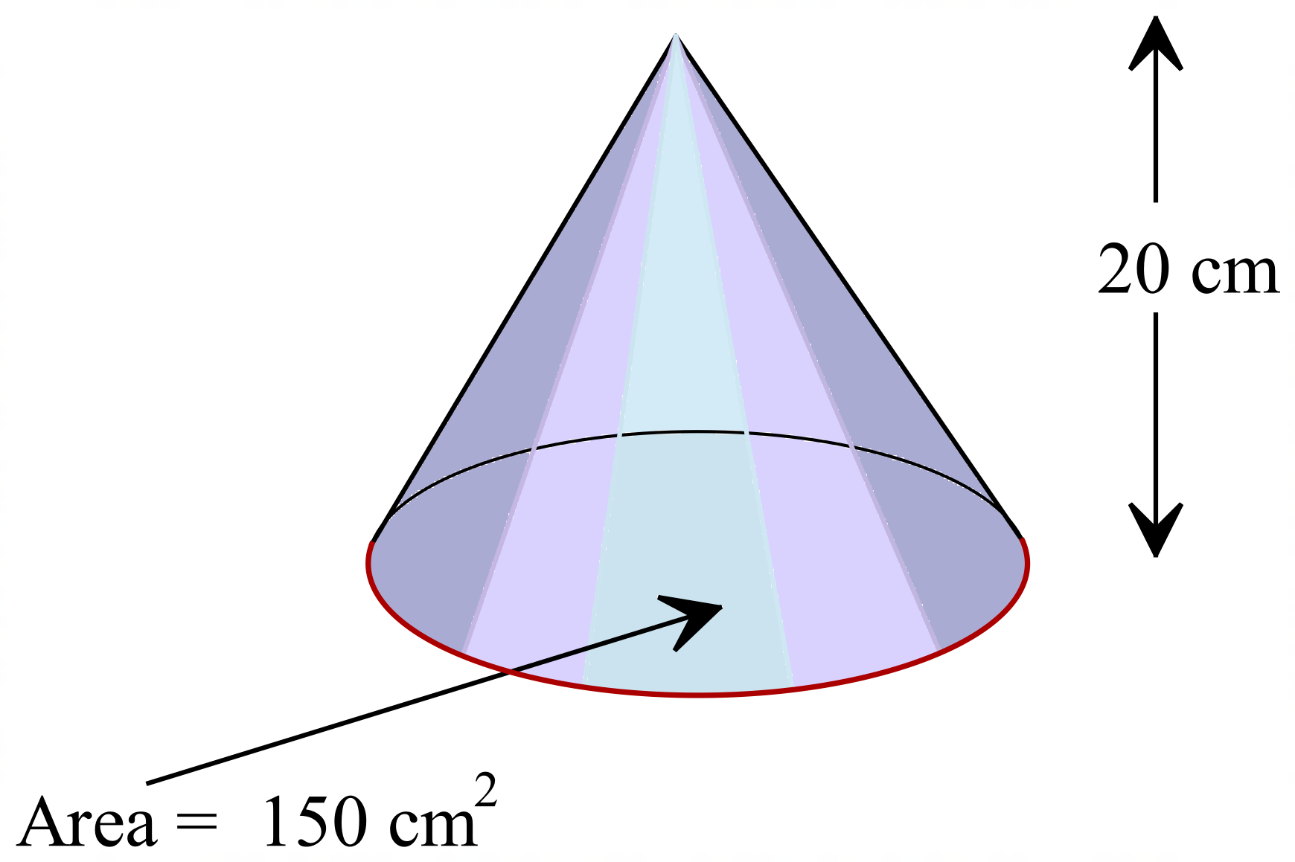What is its volume?

A. 300 cm³
B. 600 cm³
C. 900 cm³
D. 1000 cm³

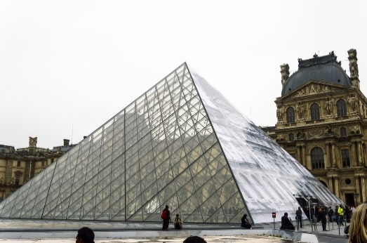
The Glass Pyramid at the Louvre in Paris has a square base which is 34 m long and the slant height of each face is 27.5 m.
What is the total surface area of its glass faces?

A. 935 m²
B. 1870 m²
C. 3740 m²
D. 5610 m²
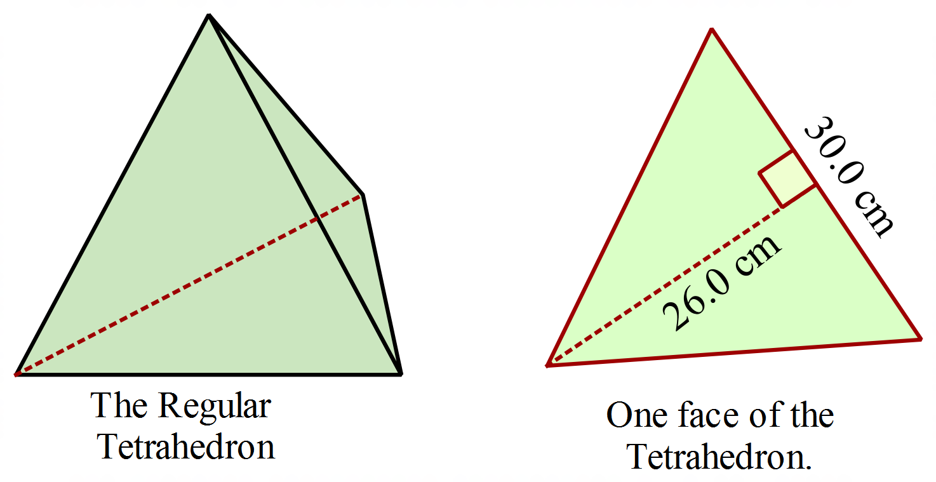A regular tetrahedron (a special triangular pyramid) has 4 congruent triangular faces.
The dimensions (to the nearest half cm) of one face of the tetrahedron are shown on the diagram.
Its perpendicular height of the pyramid is 24.5 cm
What is the volume of the regular tetrahedron?

A. 390 cm³ B. 1560 cm³ C. 9555 cm³ D. 19 110 cm³
A paperweight is in the shape of the square pyramid, shown.
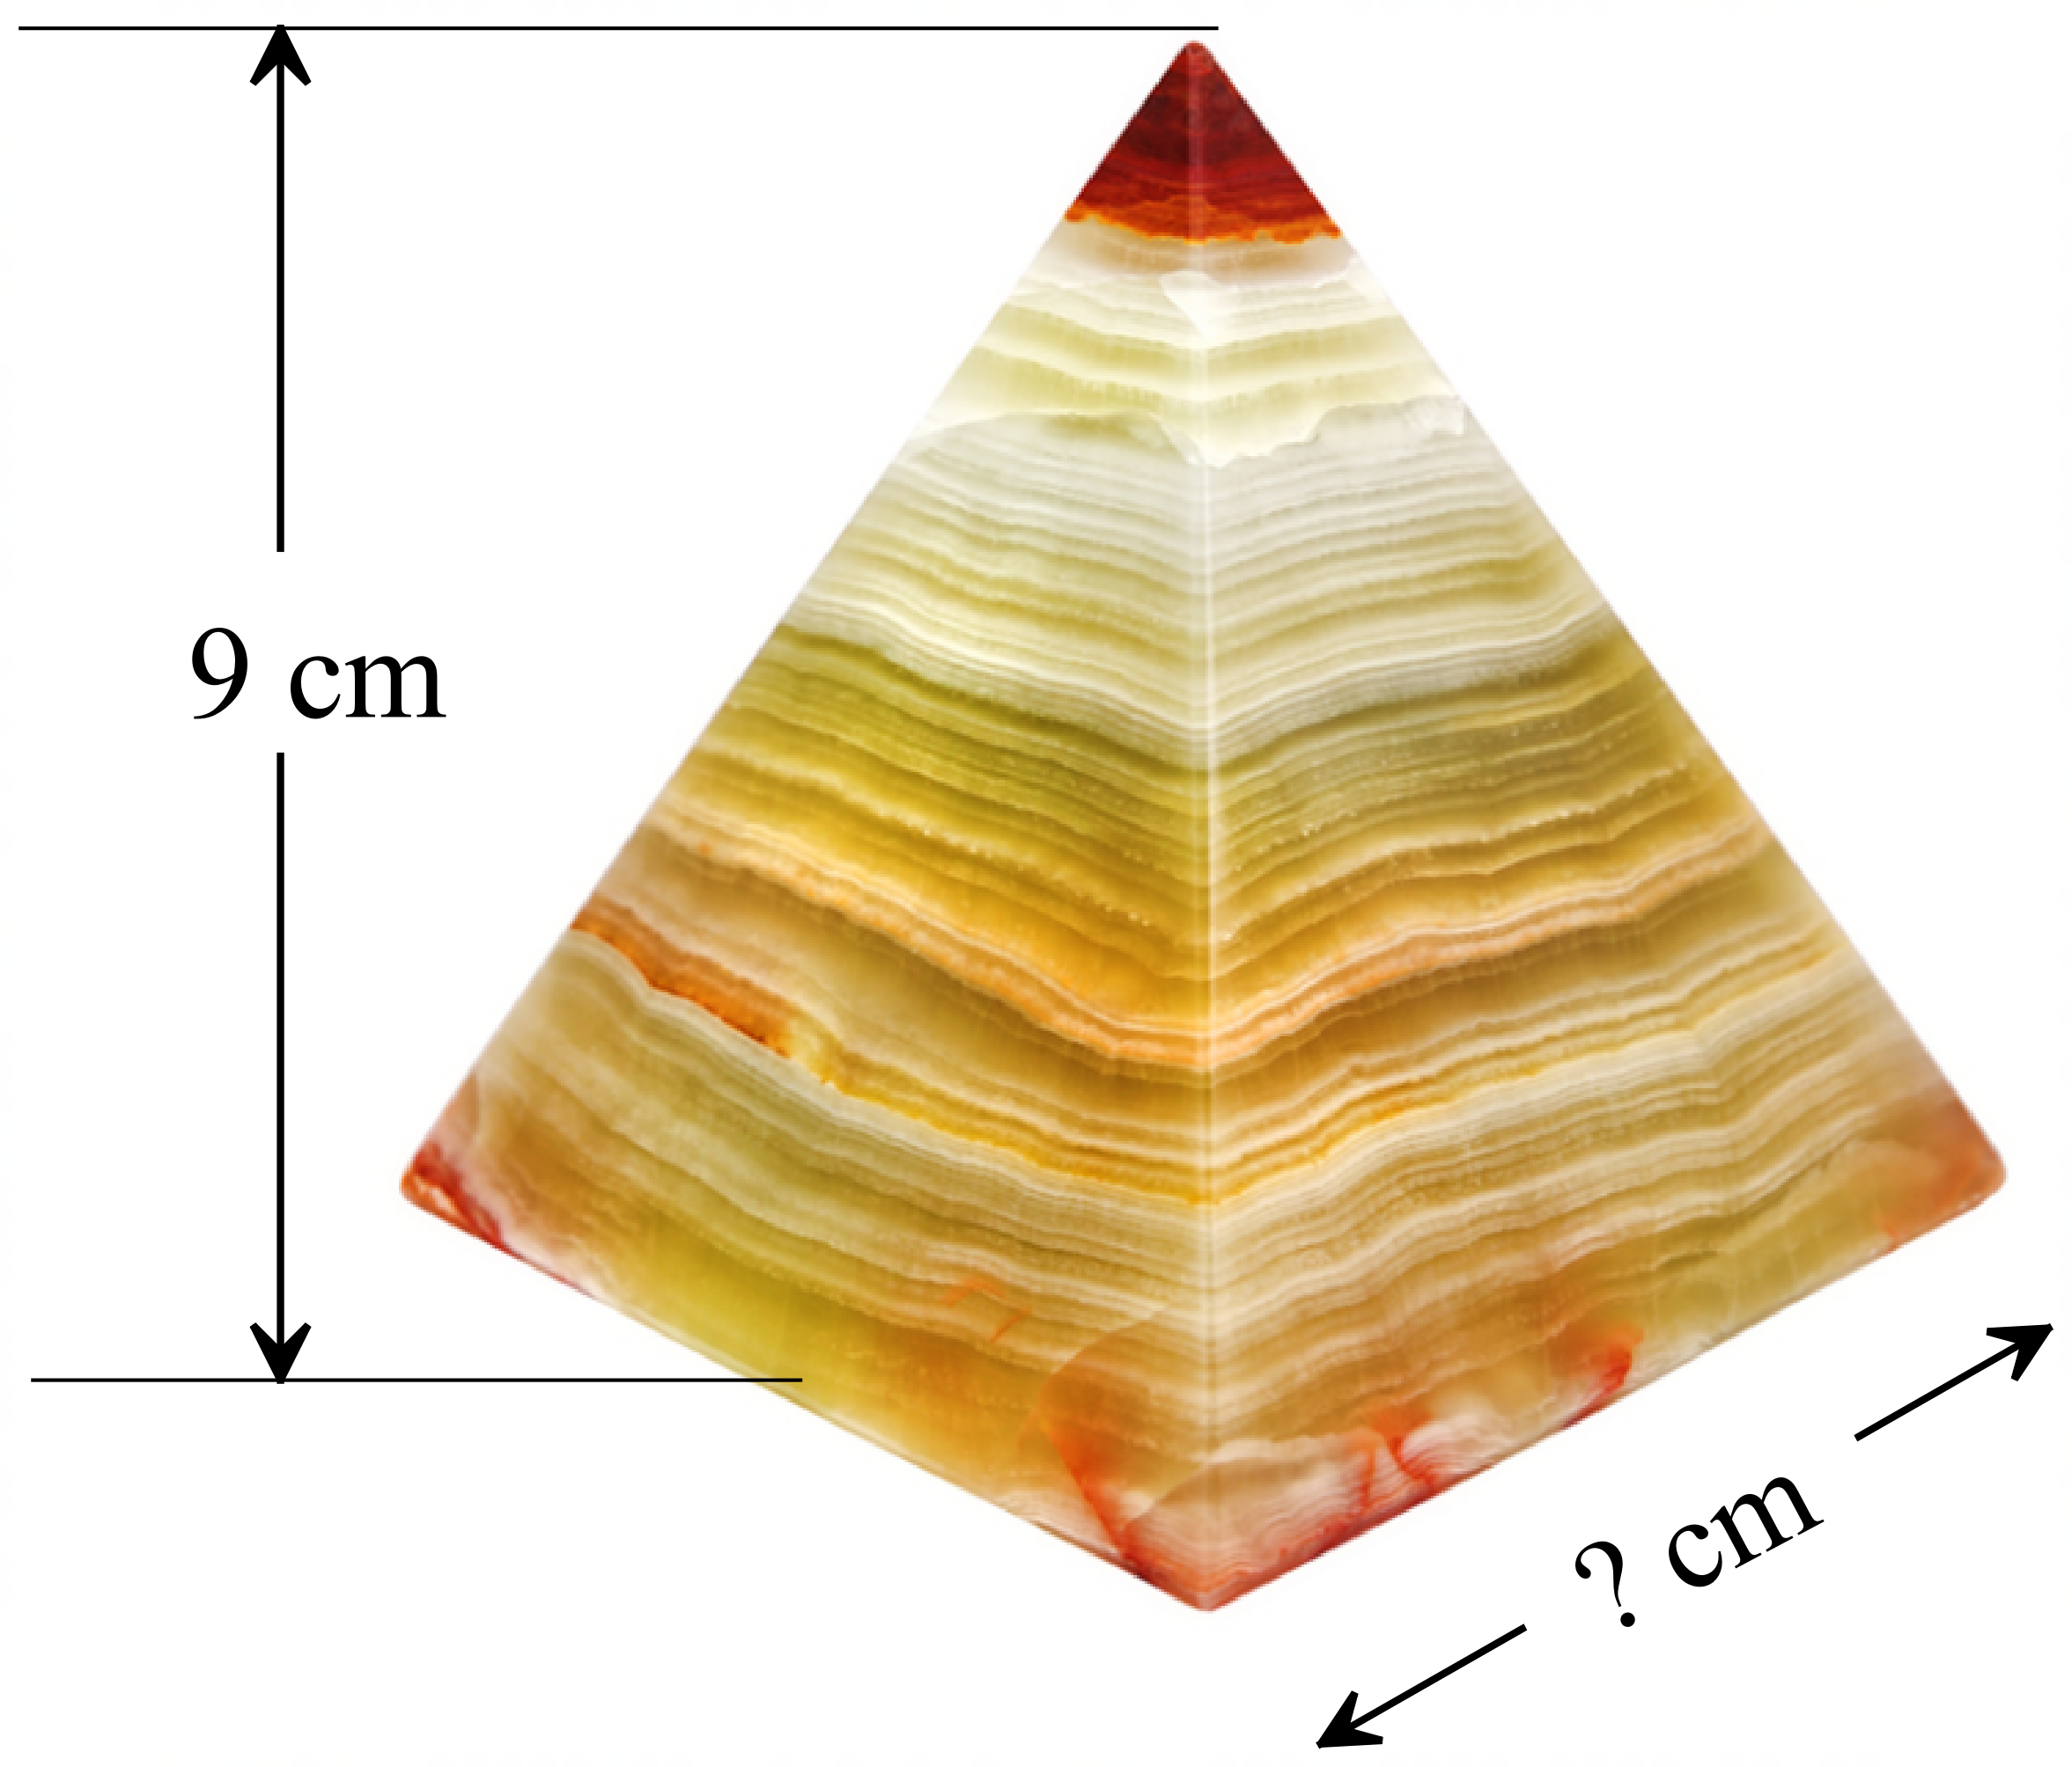Its perpendicular height is 9 cm and its volume is 192 cm³.
How long are the base edges of the pyramid?

A. 8 cm
B. 16 cm
C. 21.3 cm
D. 32 cm

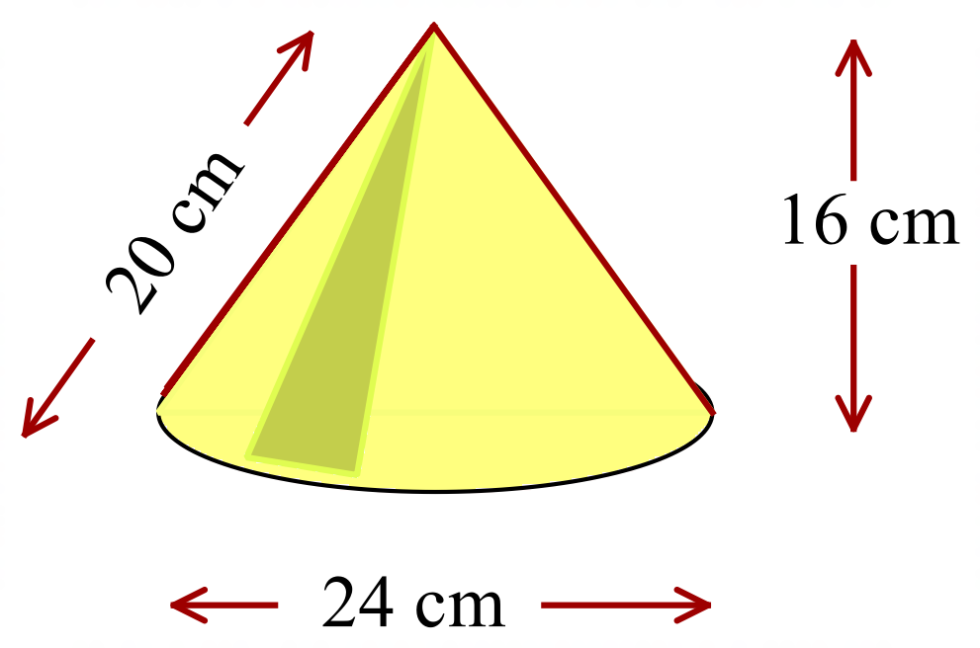Which calculation would give the total surface area of this cone?

A.
B.
C.
D.
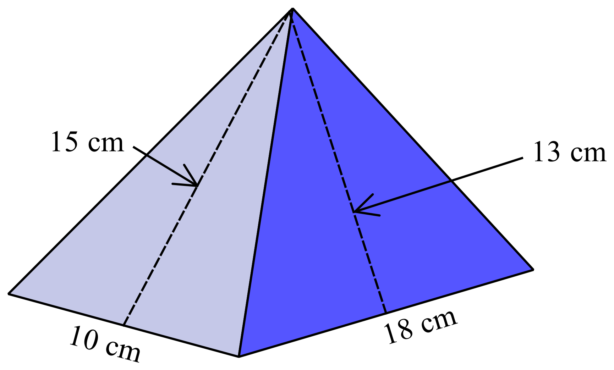What is the surface area of the rectangular pyramid shown?

A. 330 cm²
B. 510 cm²
C. 534 cm²
D. 564 cm²

A decorative concrete ball in a garden has a diameter of 0.5 m.
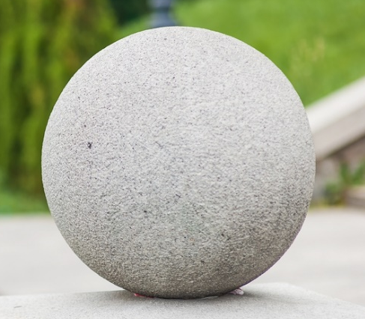
A cubic metre of concrete weighs 2400 kg.
How much does the concrete ball weigh?

A. 157 kg
B. 628 kg
C. 1257 kg
D. 1885 kg
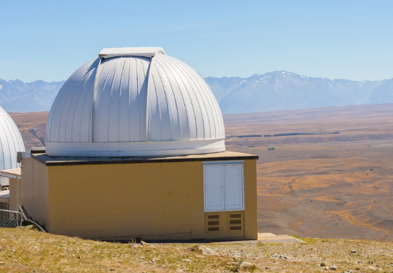
The dome this observatory in NZ can be approximated by a hemisphere of diameter 12 metres.
What is the surface area of the dome (in terms of 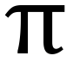)?

A. 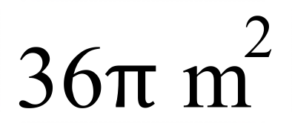
B. 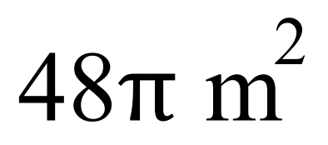
C. 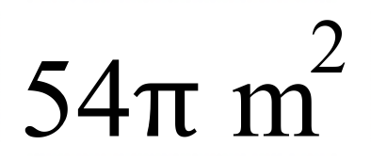
D. 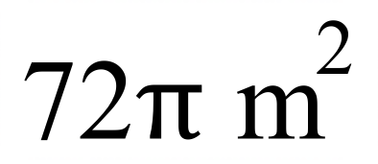
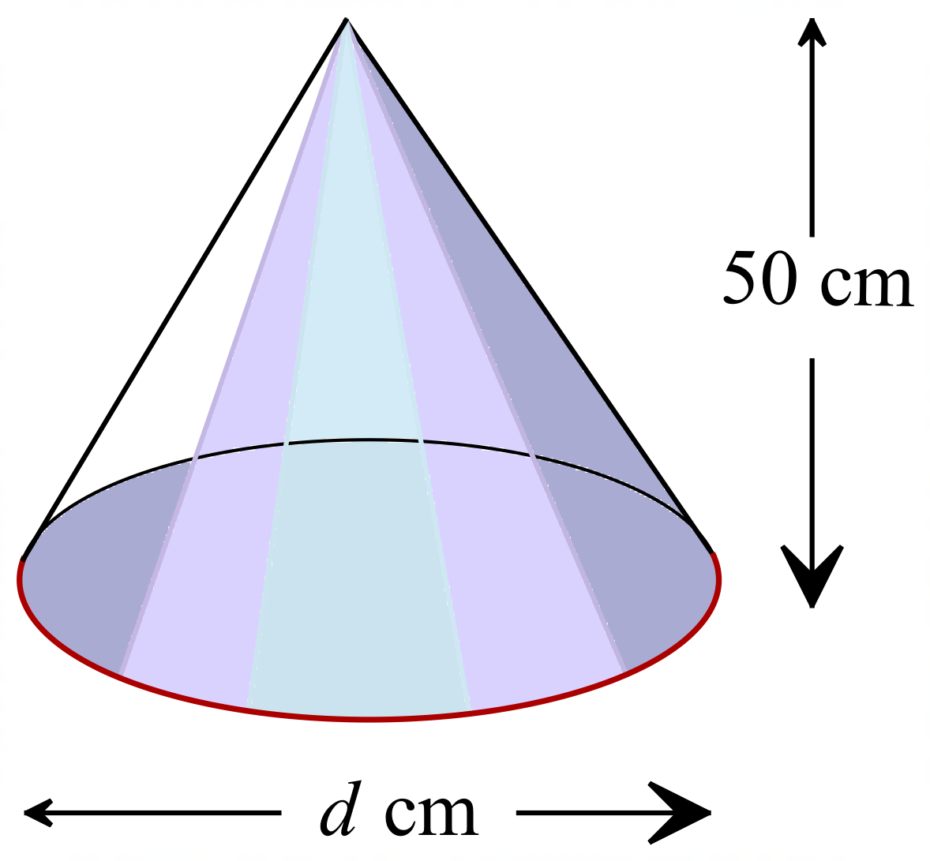This cone has a volume of 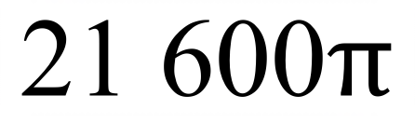 cm³.
What is the diameter of its base?

A. 36 cm
B. 48 cm
C. 60 cm
D. 72 cm
The square pyramid shown has base edges 42 cm, and a slant height of 29 cm.
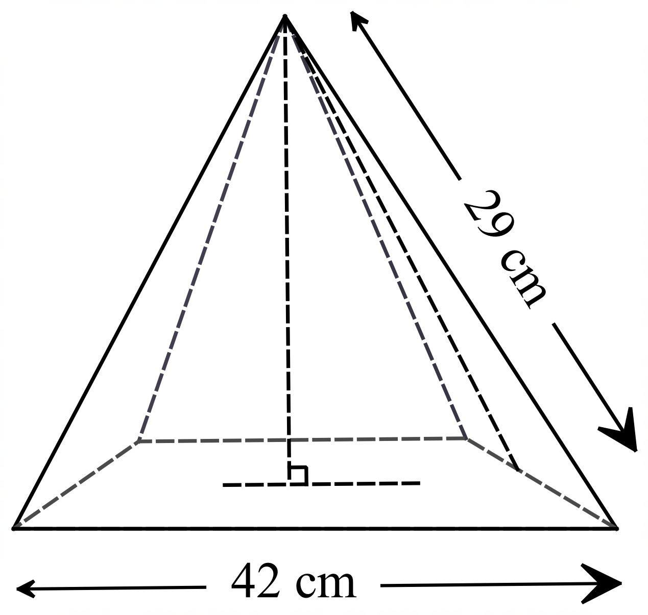Calculate the volume of the pyramid.

A. 11 760 cm³
B. 13 230 cm³
C. 17 052 cm³
D. 35 280 cm³

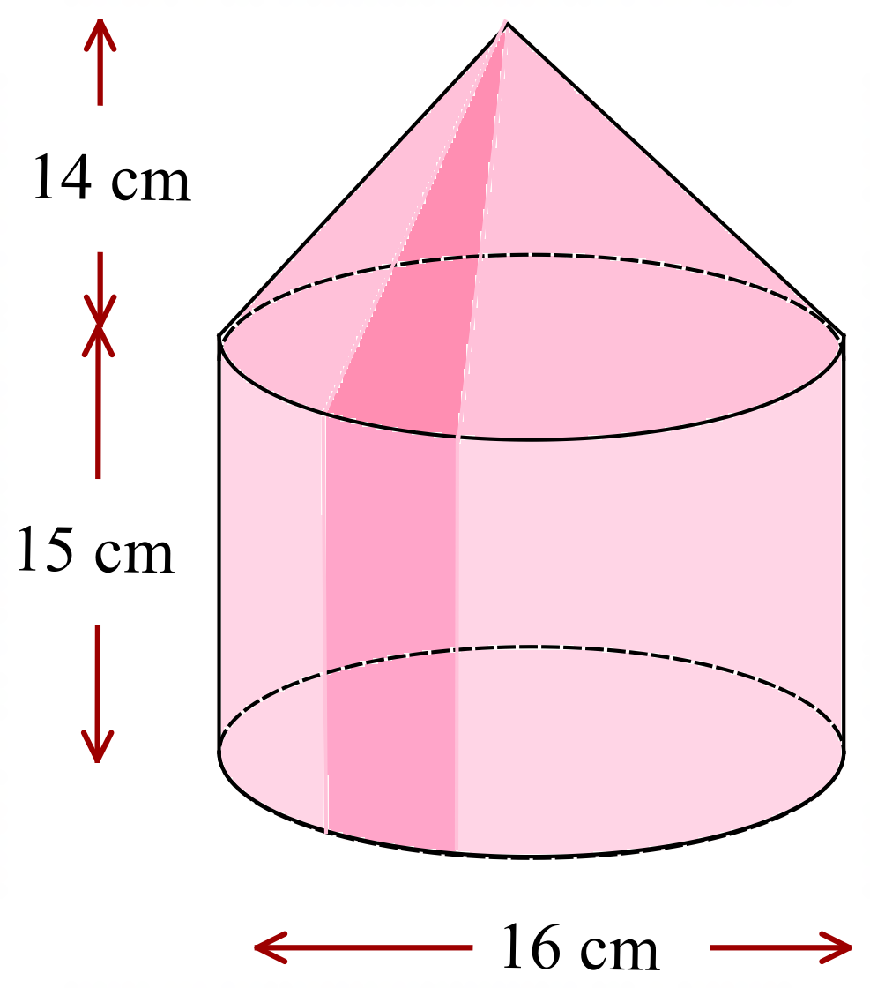What is the volume of the solid shown?

A. 3016 cm³
B. 3820 cm³
C. 3954 cm³
D. 5831 cm³

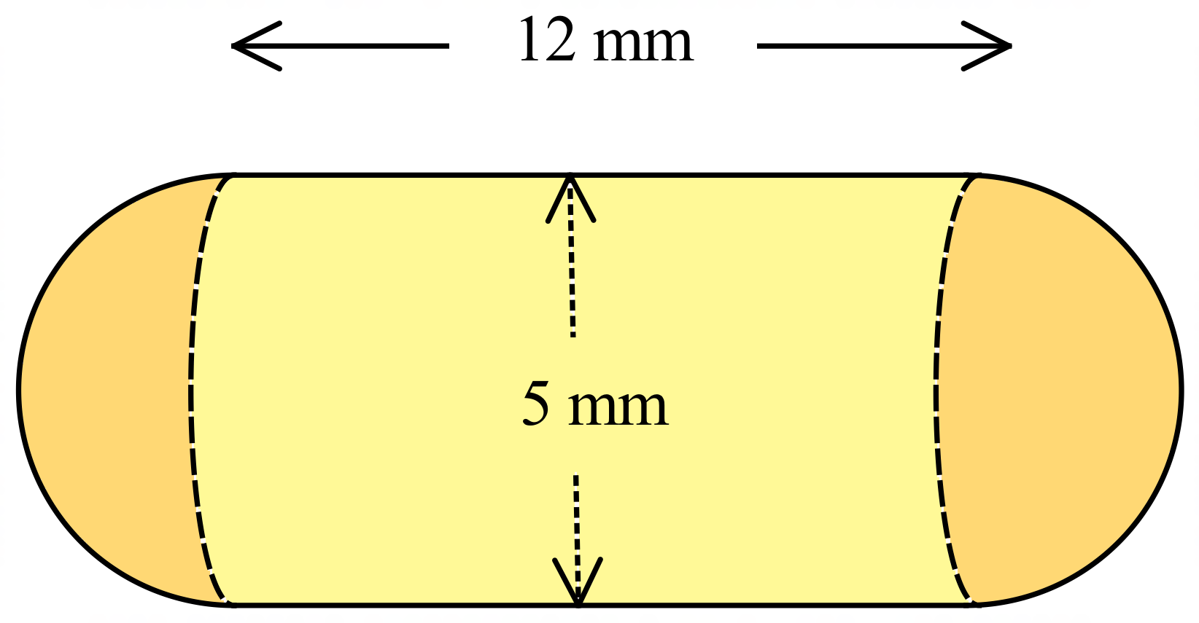The capsule for pain medication is in the shape of a cylinder with hemispherical ends, as shown.

What is the surface area of the capsule?

A. 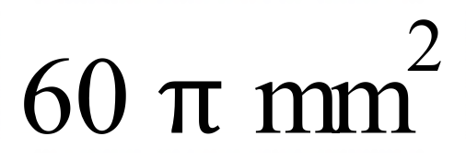
B. 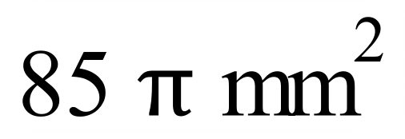
C. 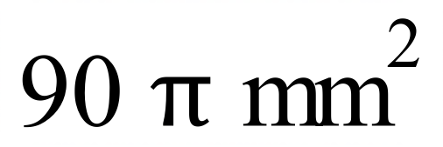
D. 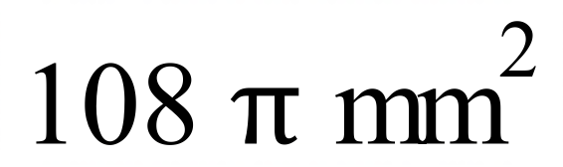

School Name
Mathematics Test 2017
Year 10 | Volume and Surface Area of Other Solids | Calculator Allowed
Year 10 | Volume and Surface Area of Other Solids | Name___________________
Section 3 Longer Answer Section
Write all working and answers in the spaces provided on this test paper.

 |  | Marks
1. | The cone below has a base which measures 54 cm and has a perpendicular height of 36 cm.  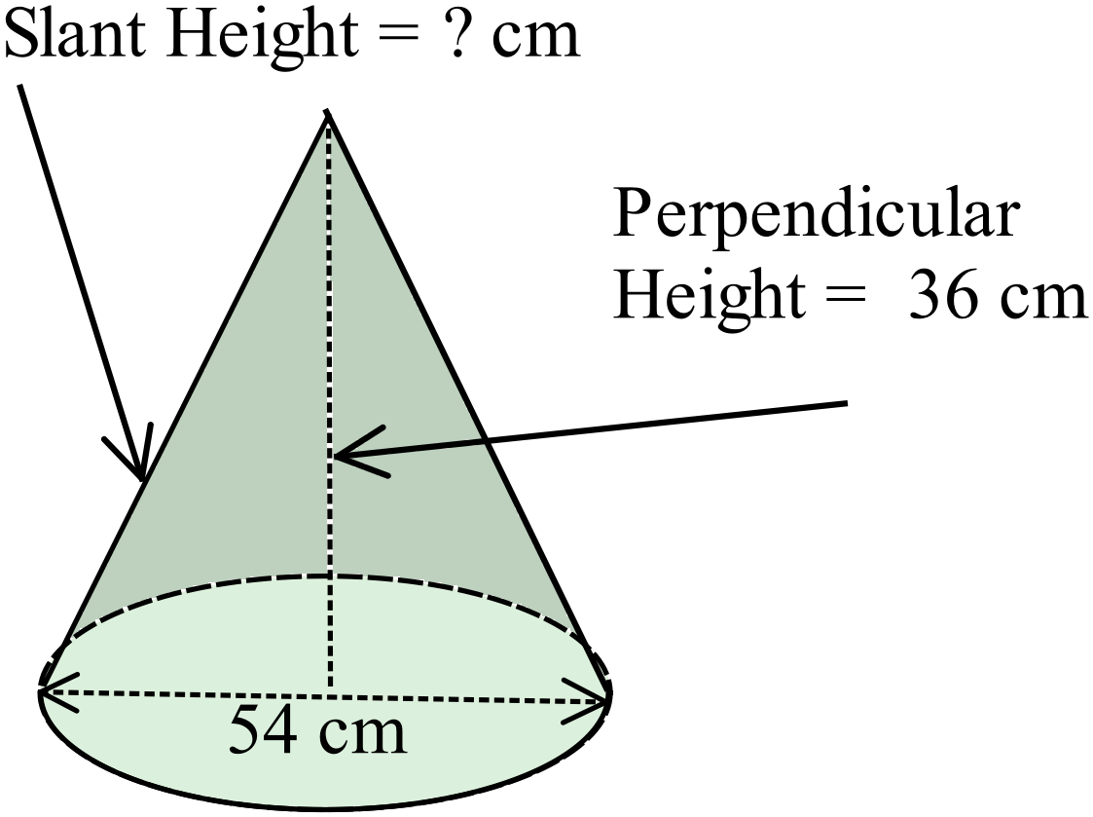
 | (a) Calculate the volume of the cone.  ……………………………………………………………………………………..  …………………………………………………………………………………….. | 1
 | (b) Calculate the slant height of the cone.  ……………………………………………………………………………………..  …………………………………………………………………………………….. | 1
 | (c) Calculate the surface area of the cone.  ……………………………………………………………………………………..  ……………………………………………………………………………………..  …………………………………………………………………………………….. | 2
2. | The rectangular pyramid below has a base which measures 60 cm by 18 cm and has a perpendicular height of 40 cm.  The slant height of the left hand triangular face is 50 cm.  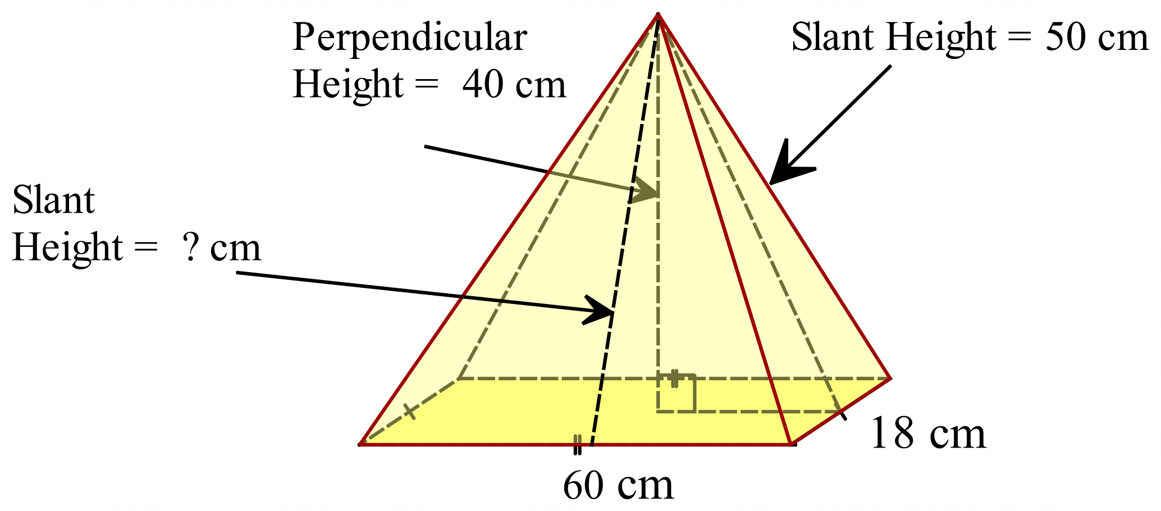
 | (a) Calculate the volume of the pyramid.  ……………………………………………………………………………………………....  ……………………………………………………………………………………………....  ………………………………………………………………………………………………. | 1
 | (b) Calculate the slant height of the front triangular face.  ……………………………………………………………………………………………....  ………………………………………………………………………………………………. | 1
 | (c) Calculate the surface area of the pyramid.  ……………………………………………………………………………………………....  ……………………………………………………………………………………………....  ……………………………………………………………………………………………....  ………………………………………………………………………………………………. | 2

School Name
Mathematics 2017
Multiple Choice Answer Sheet
Volume and Surface Area of Other Solids
Name _____________________________________________
Completely fill the response oval representing the most correct answer.
1. A B C D
2. A B C D
3. A B C D
4. A B C D
5. A B C D
6. A B C D
7. A B C D
8. A B C D
9. A B C D
10. A B C D
11. A B C D
12. A B C D
13. A B C D
14. A B C D
15. A B C D

School Name
Mathematics Test 2017
Year 10 | Volume and Surface Area of Other Solids | Non Calculator Section
ANSWERS

Question | Working and Answer
 | 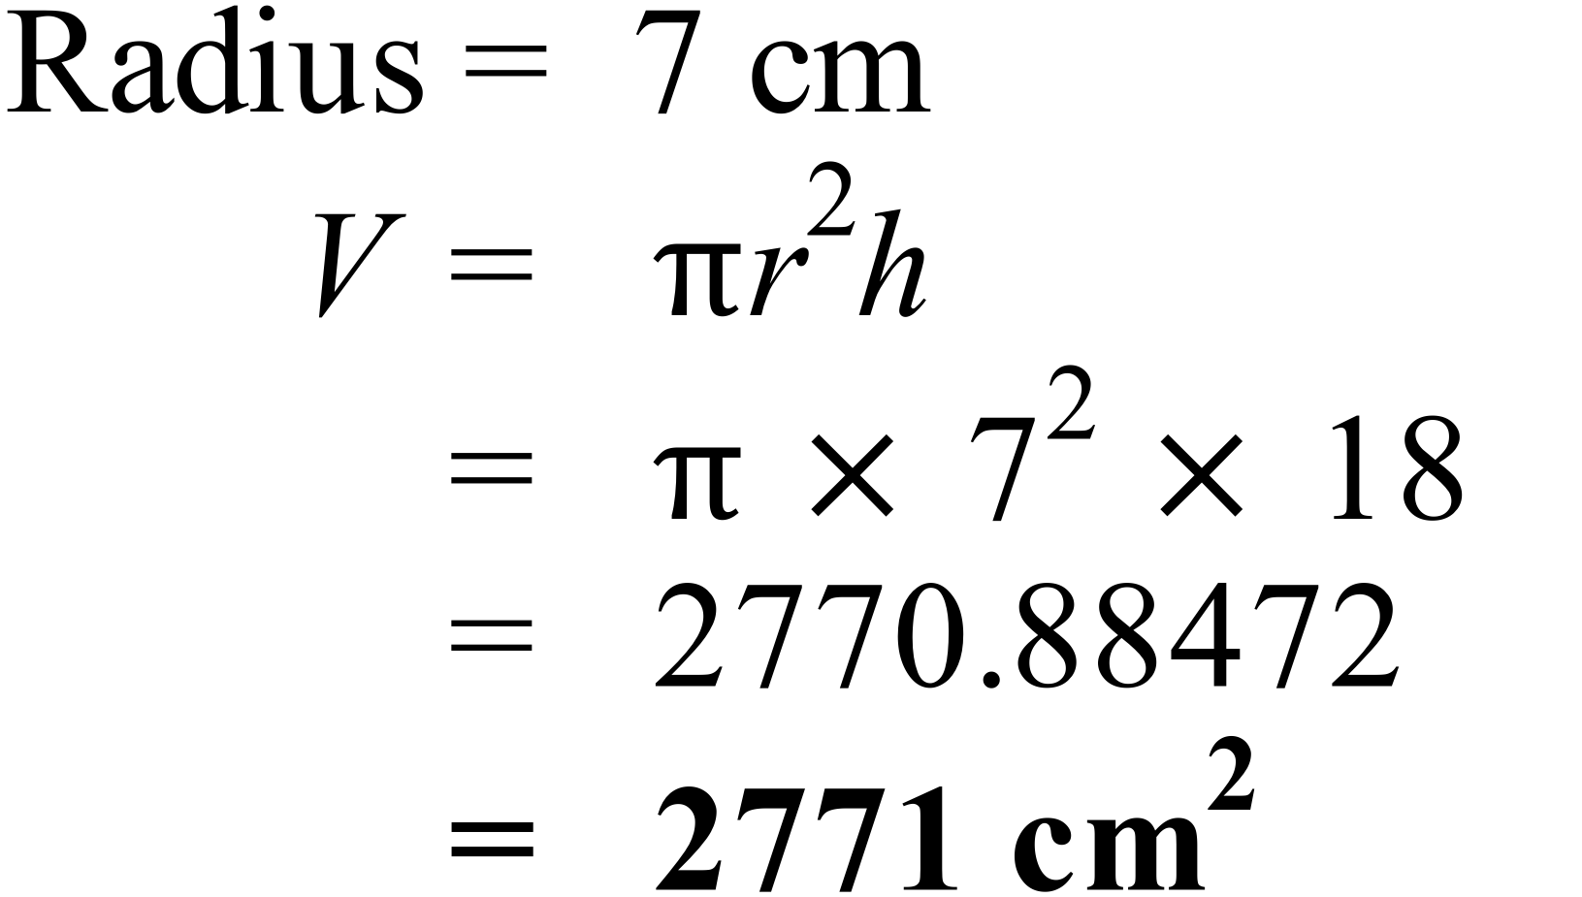
 | 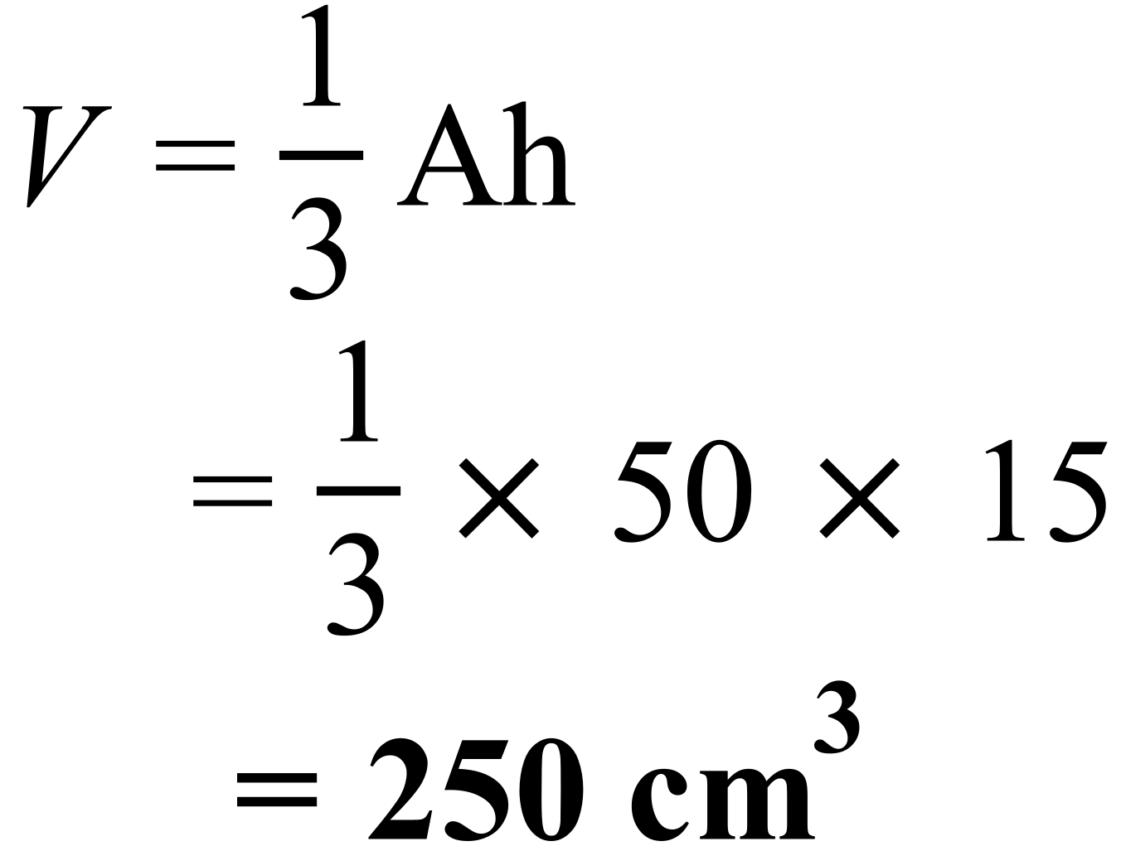
The base has 25 cubes, the next level has 9 cubes and the top has 1 cube.
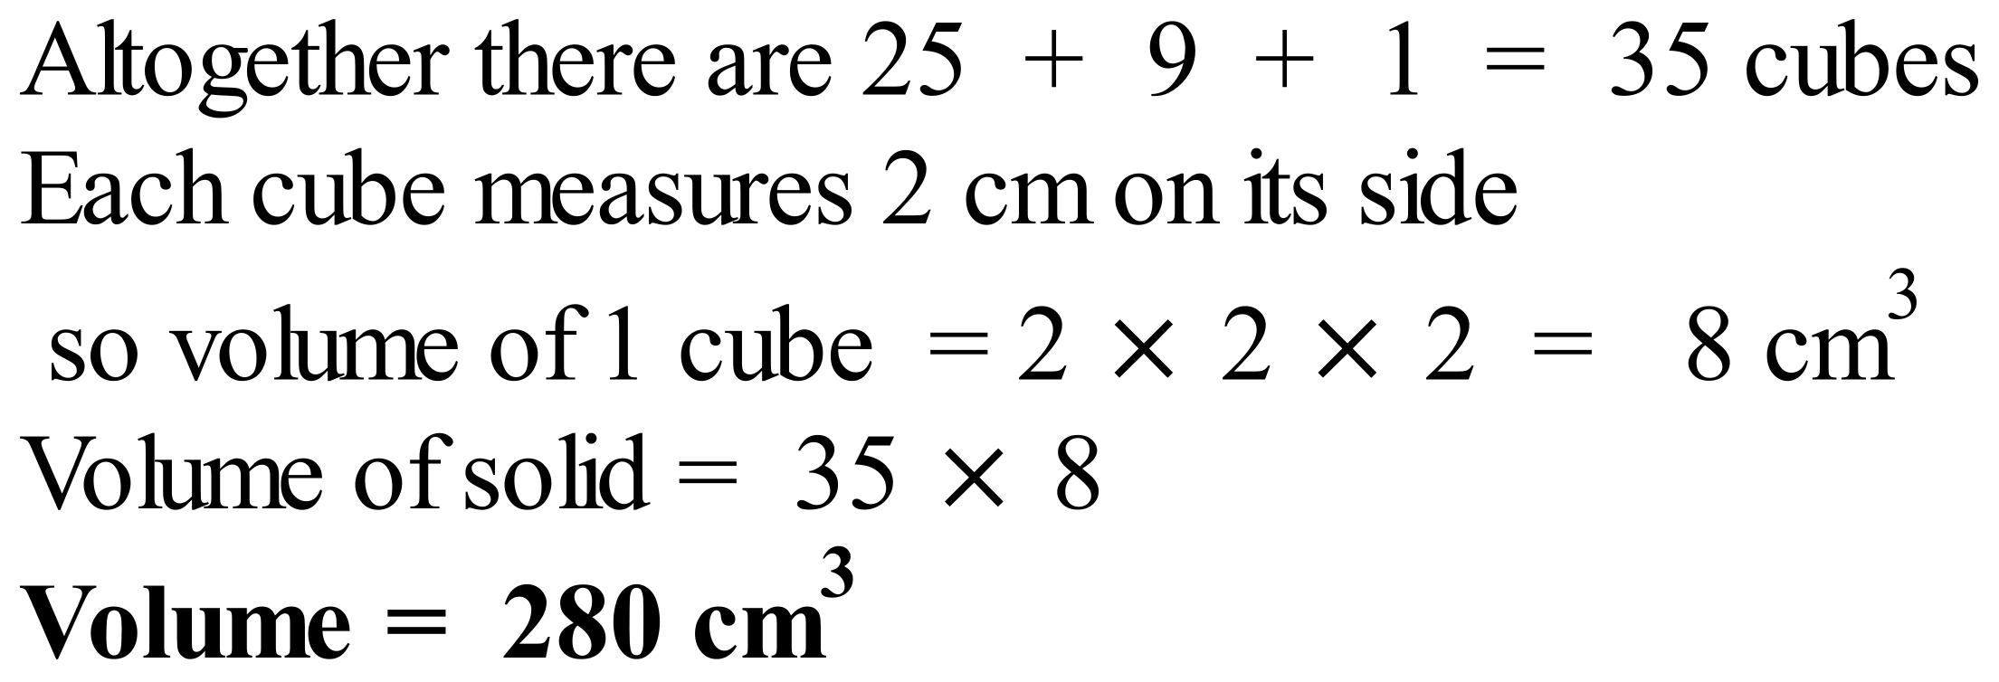
 | 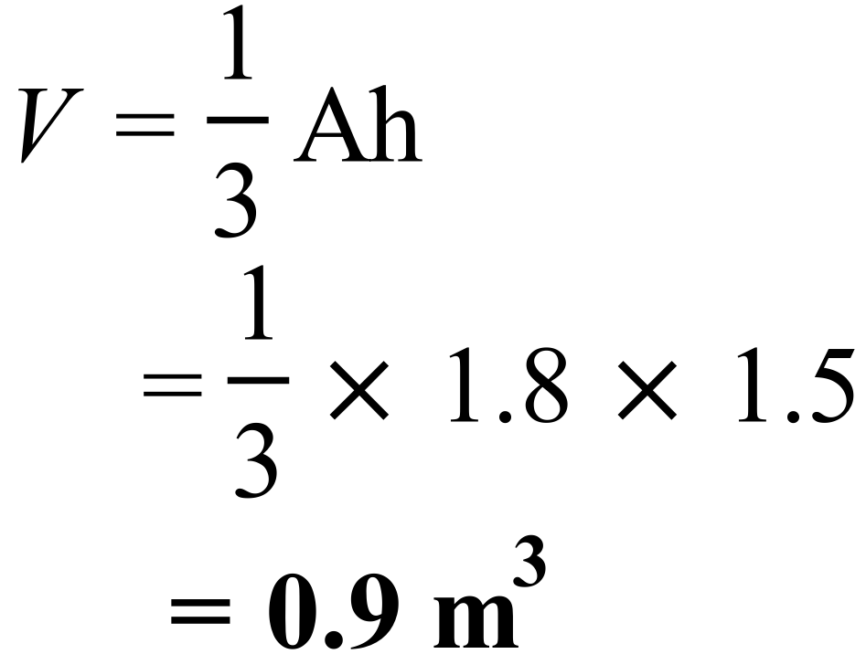
 | 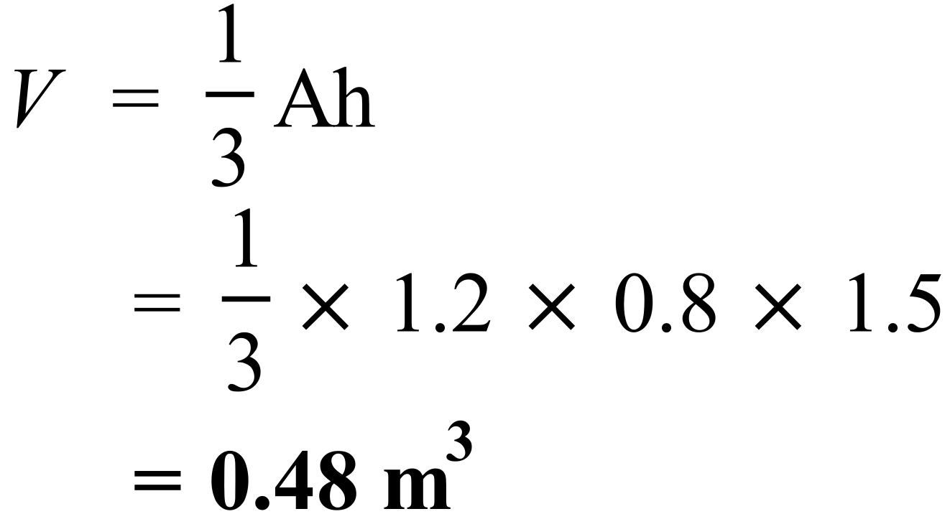
 | 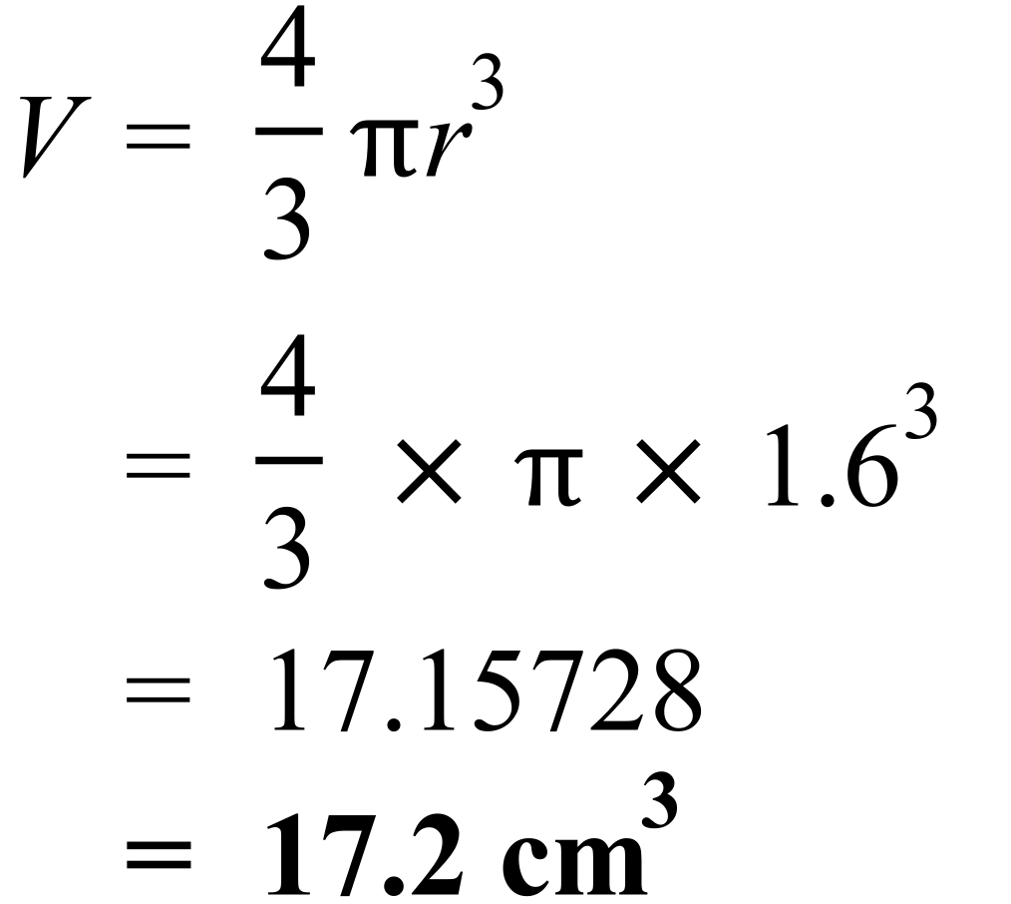
 | 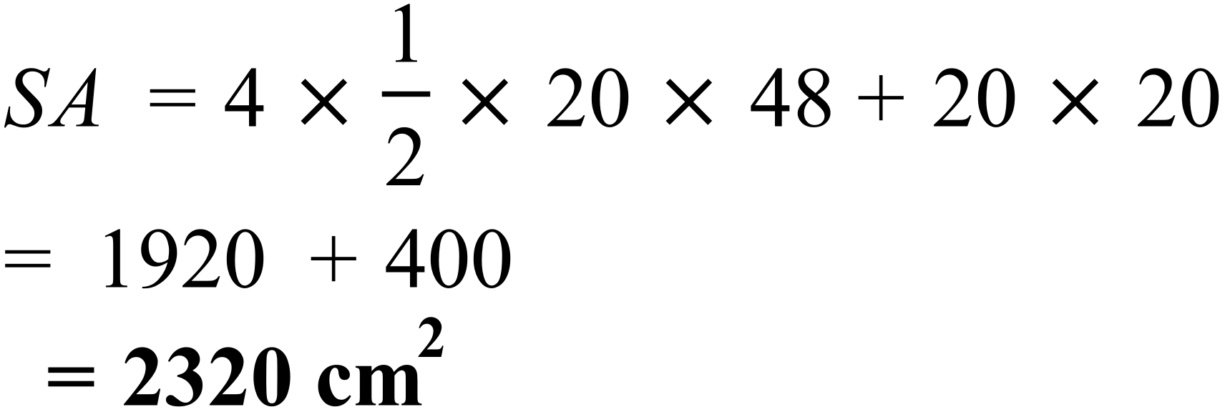
 | 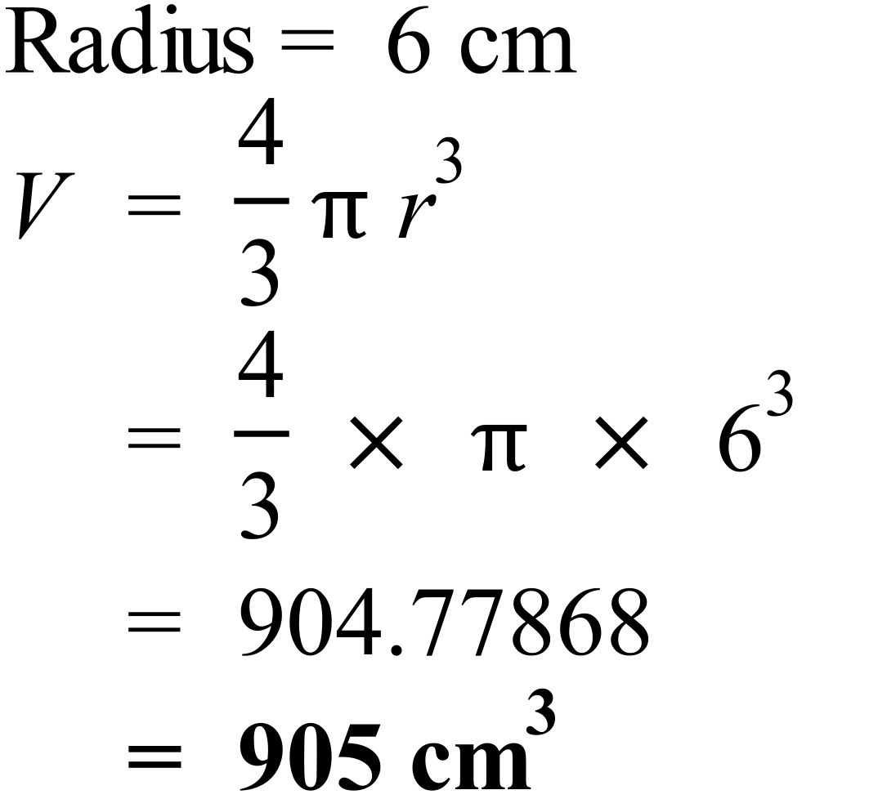
 | 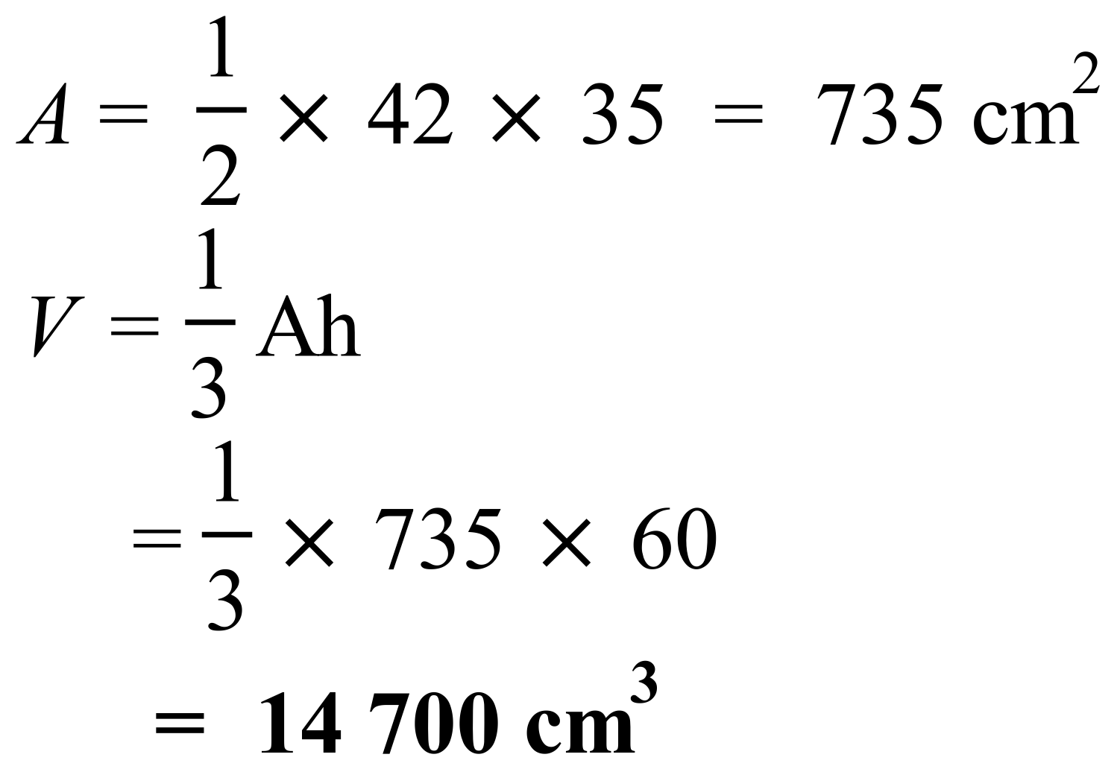
 | 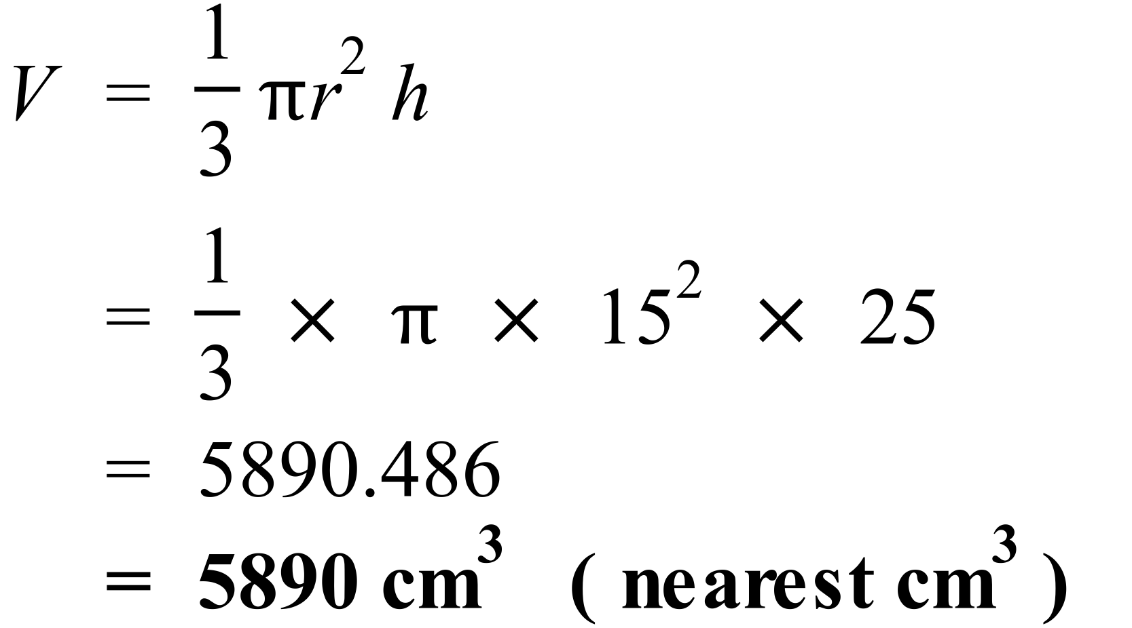
 | 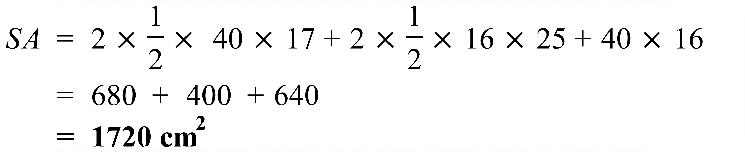
 | 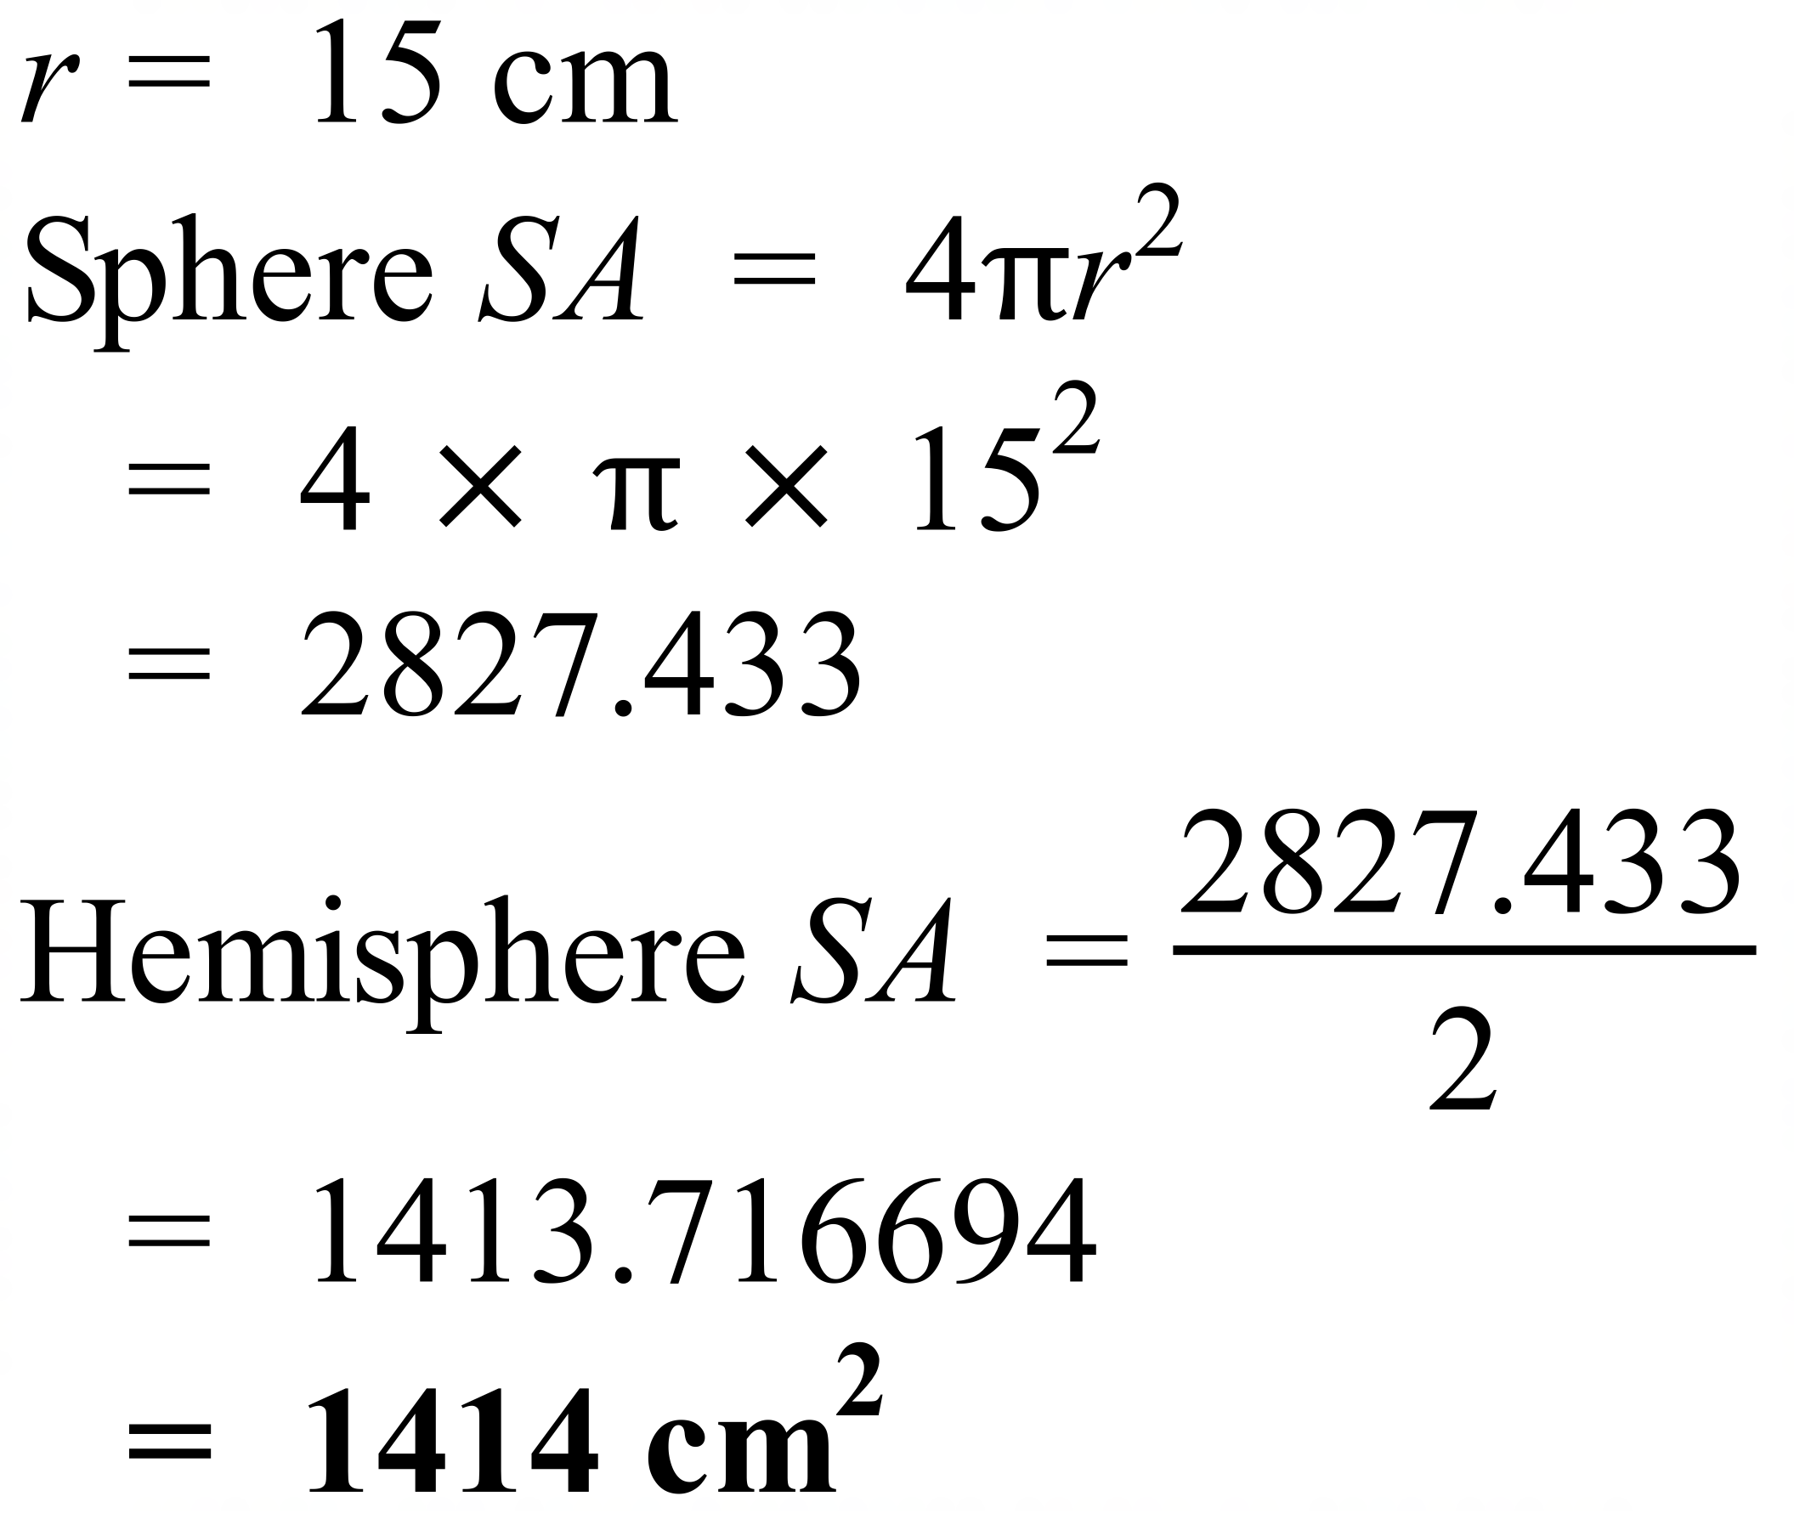
 | 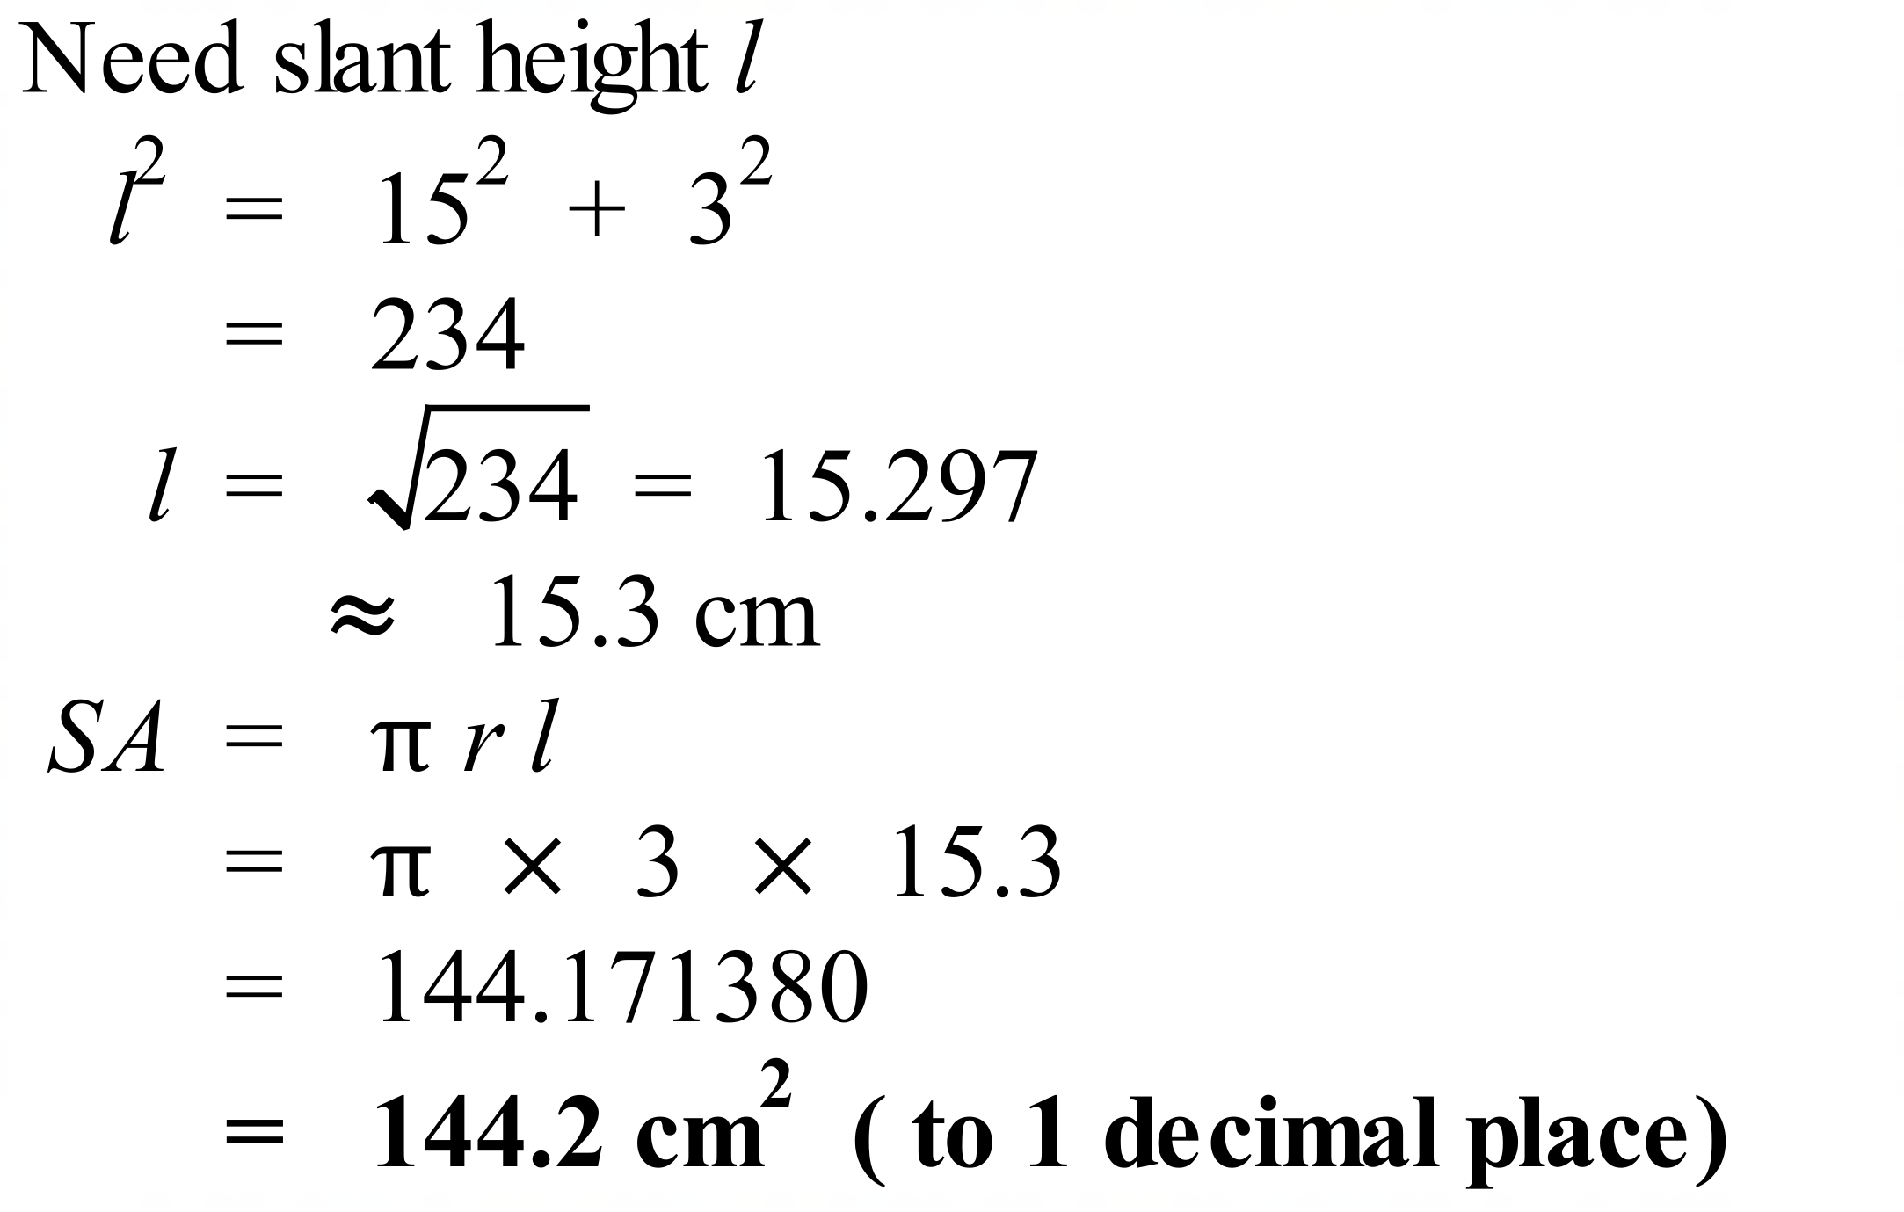
 | 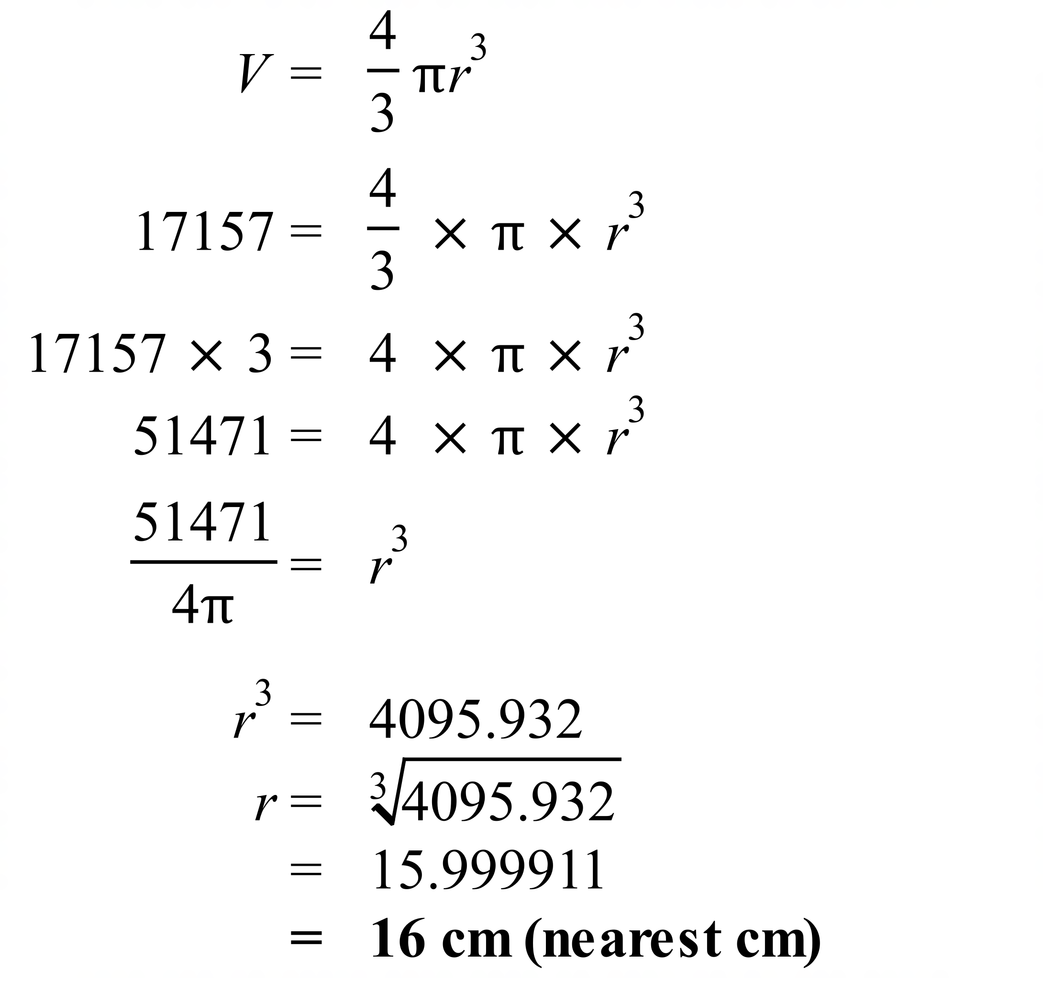
 | 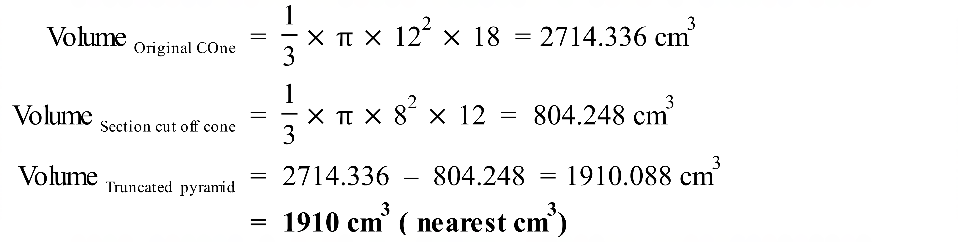

School Name
Mathematics Test 2017
Year 10 | Volume and Surface Area of Other Solids | Calculator Allowed  Multiple Choice  Section

ANSWERS

Question | Working | M C Answer
 | 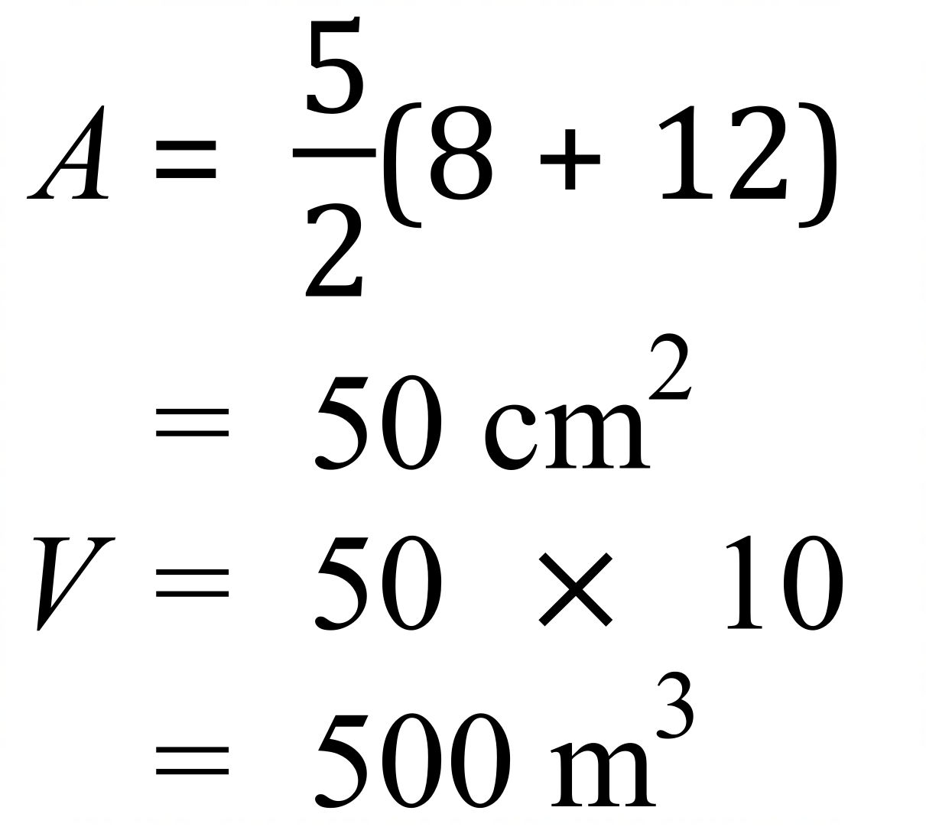 | C
 | 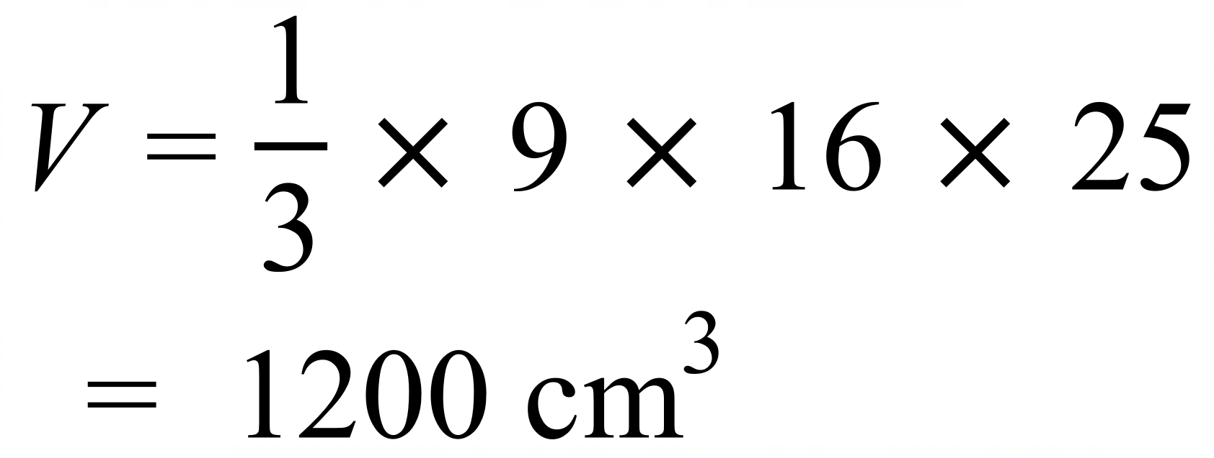 | A
 | 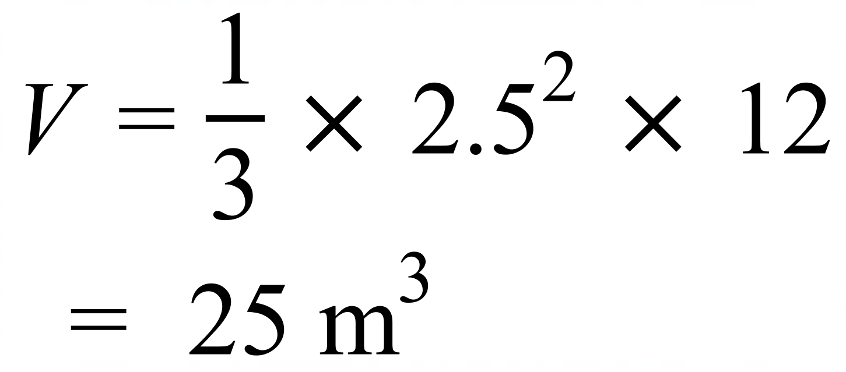 | B
 | 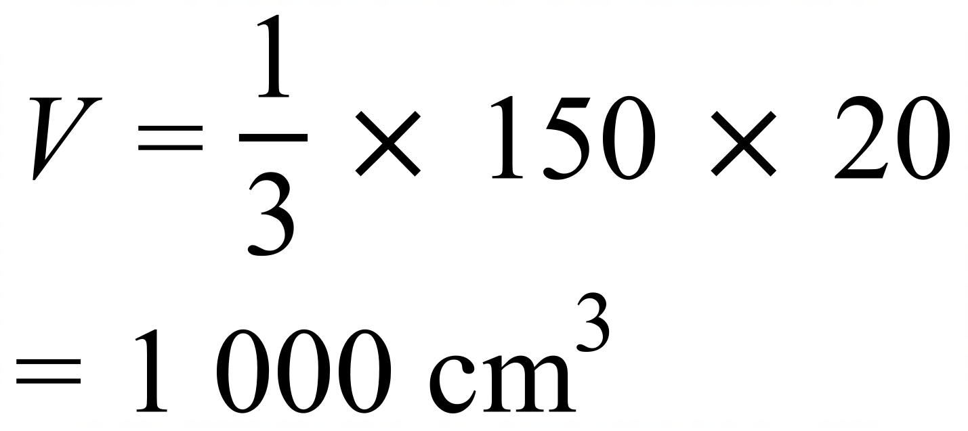 | D
 | 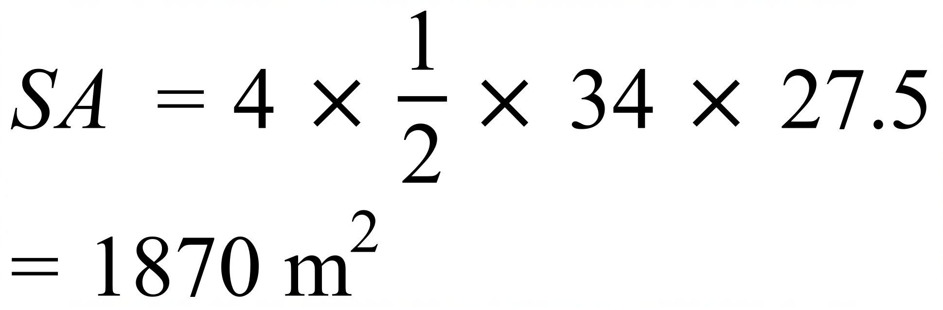 | B
 | 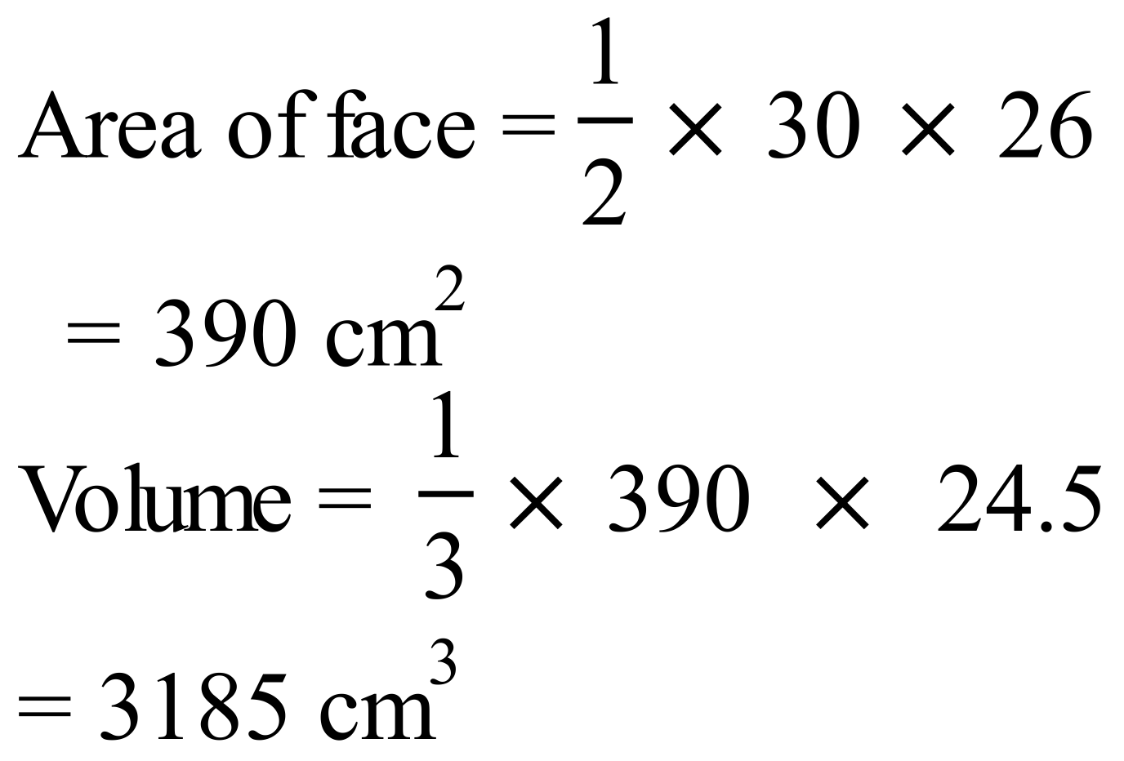 | C
 | 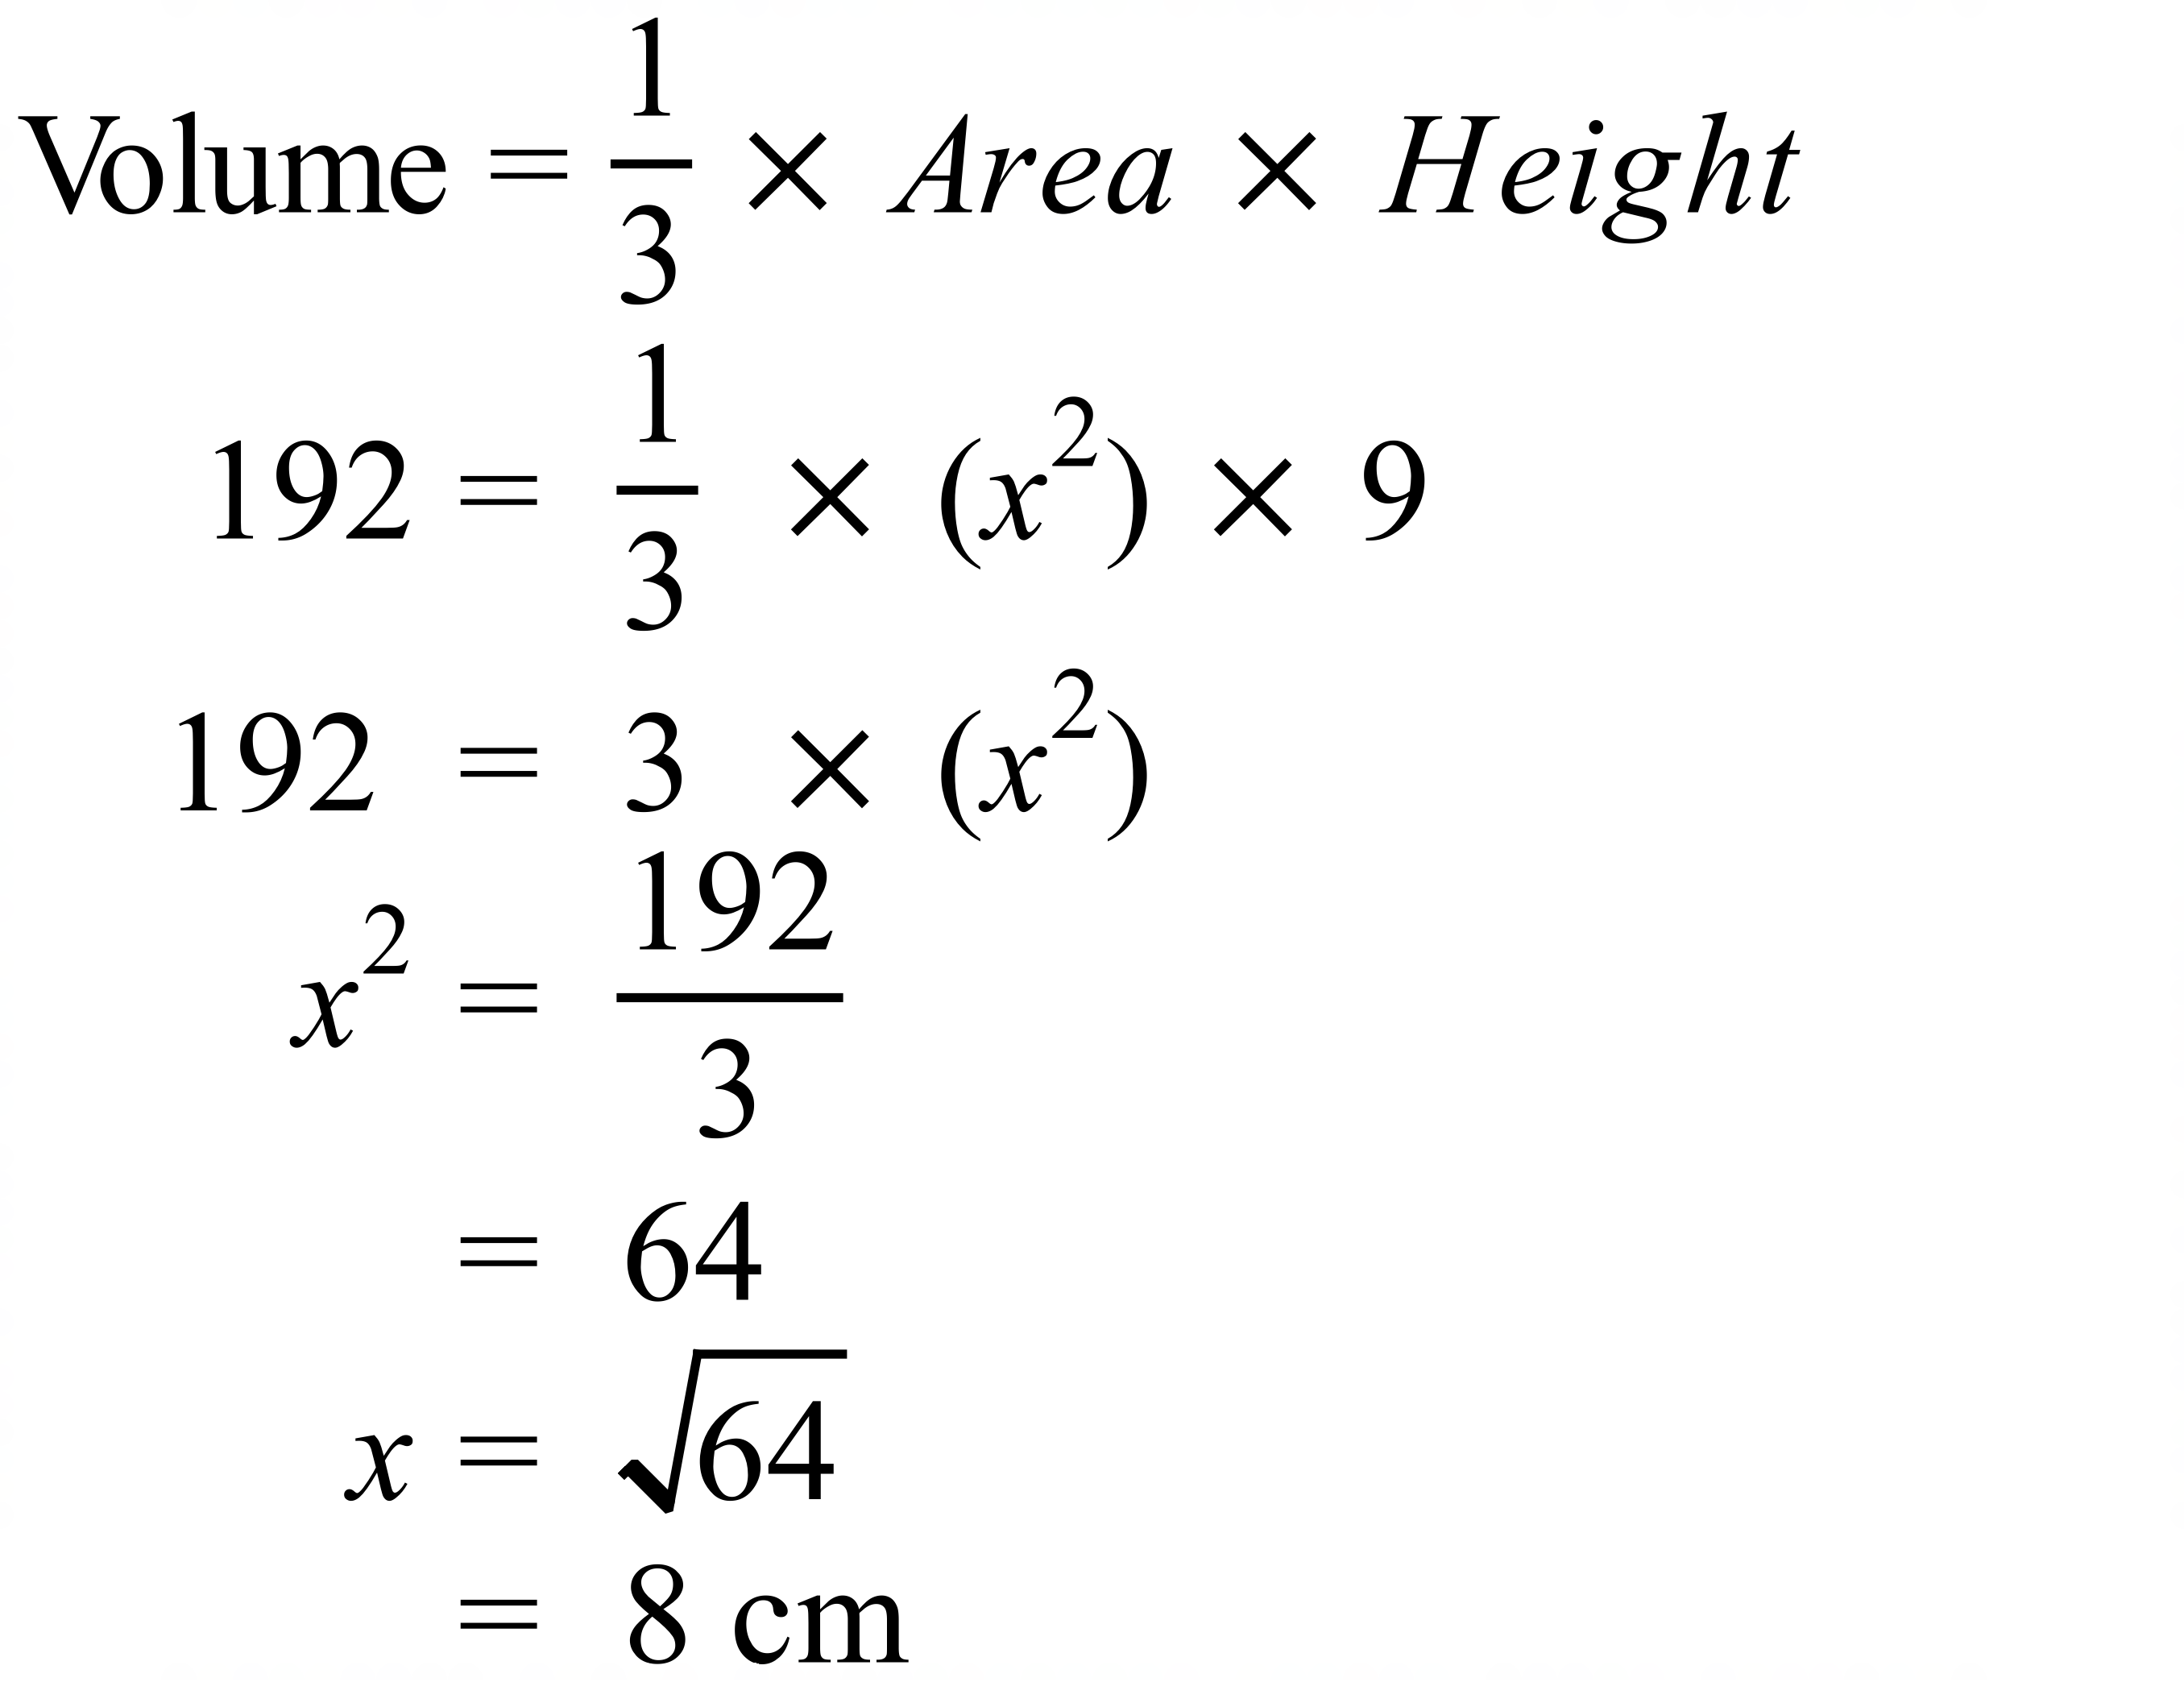 | A
 | 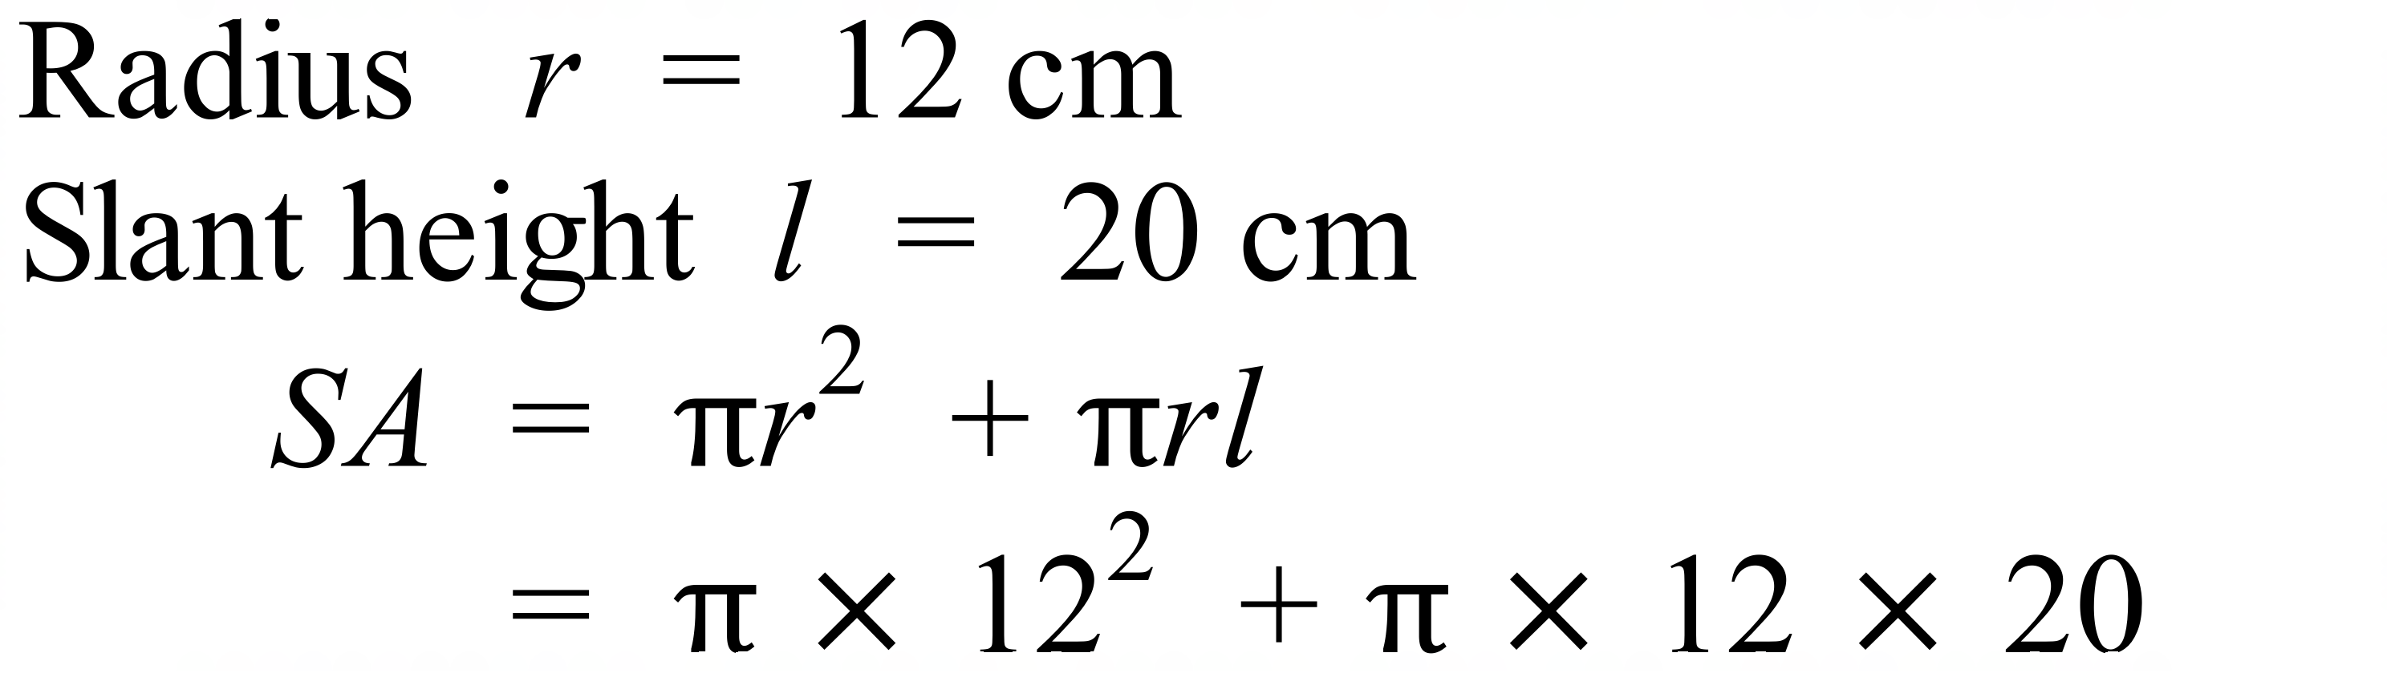 | B
 | 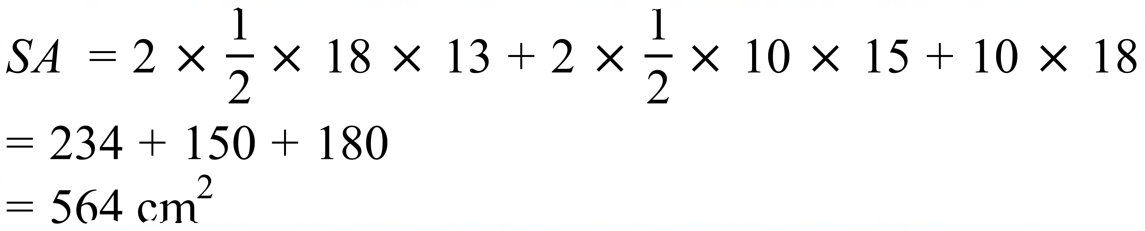 | D
 | 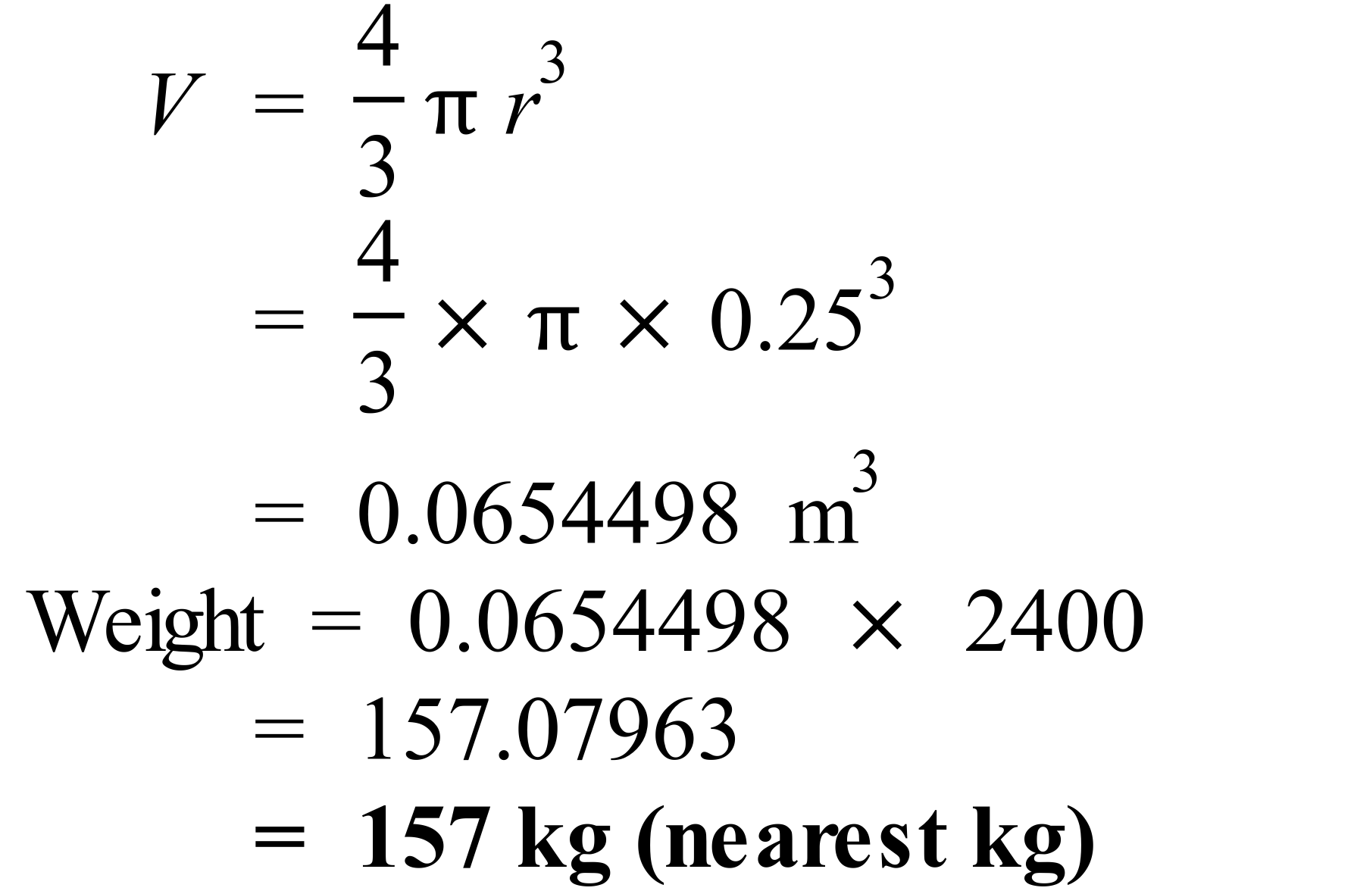 | A
 | 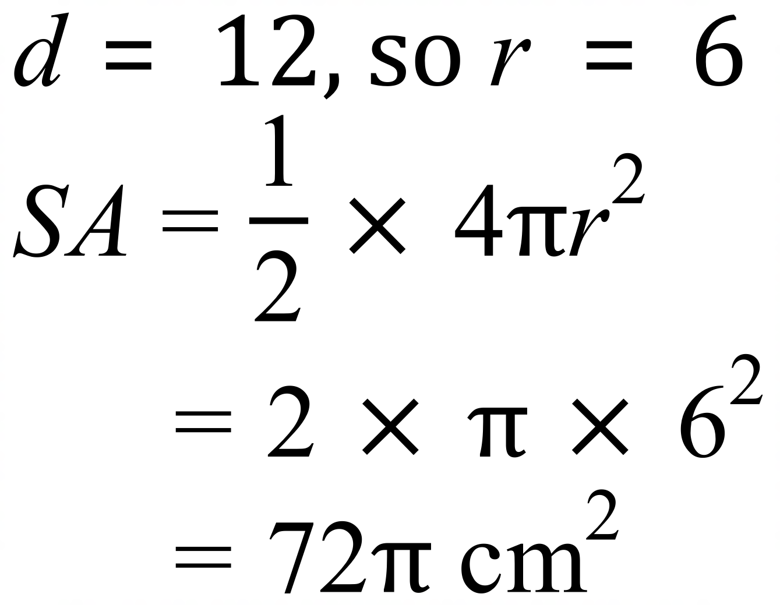 | D
 | 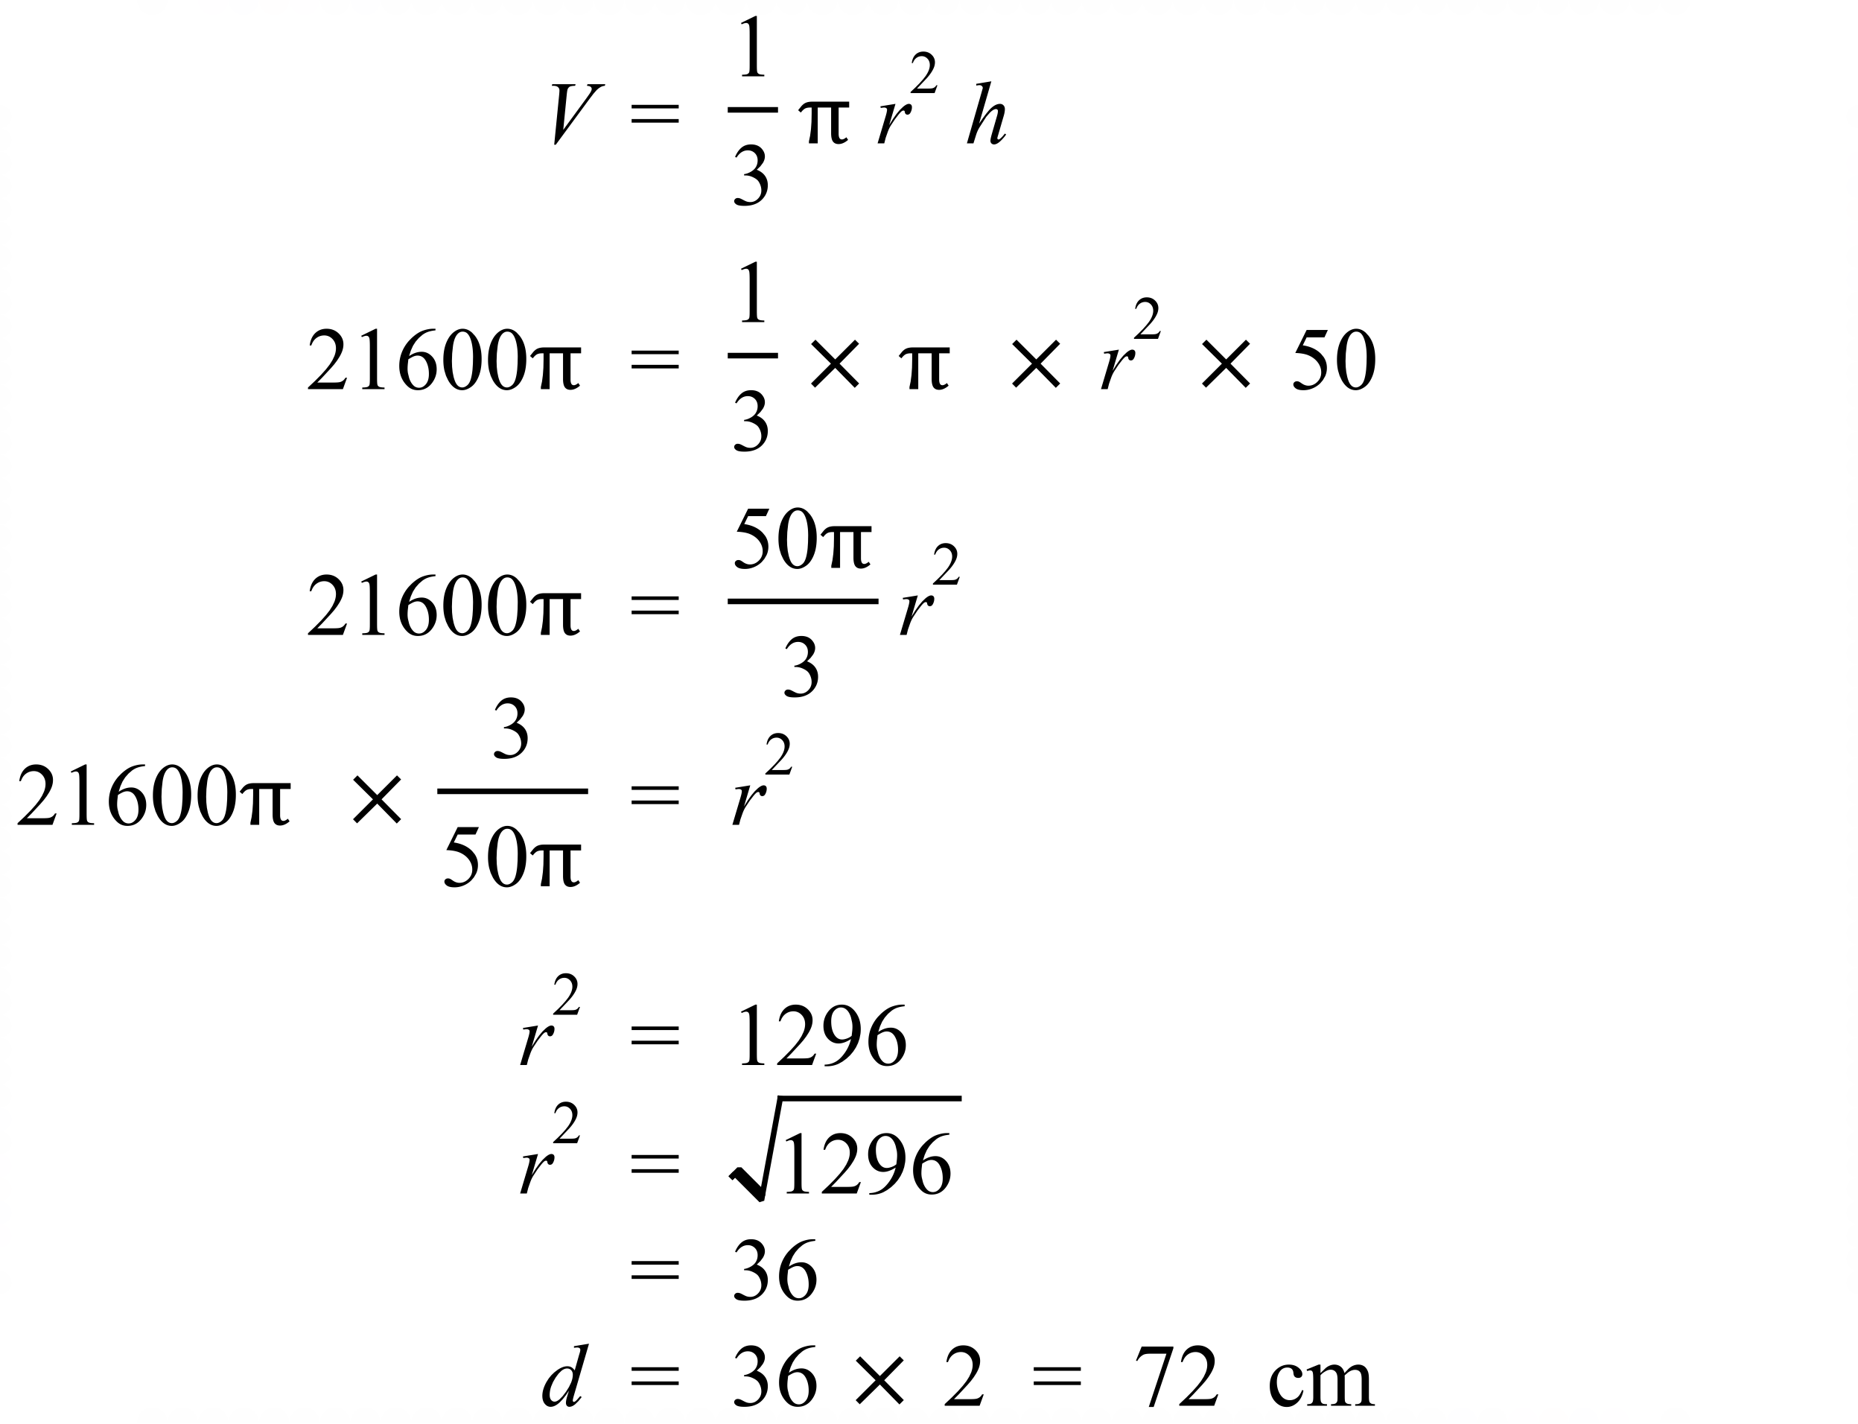 | D
 | 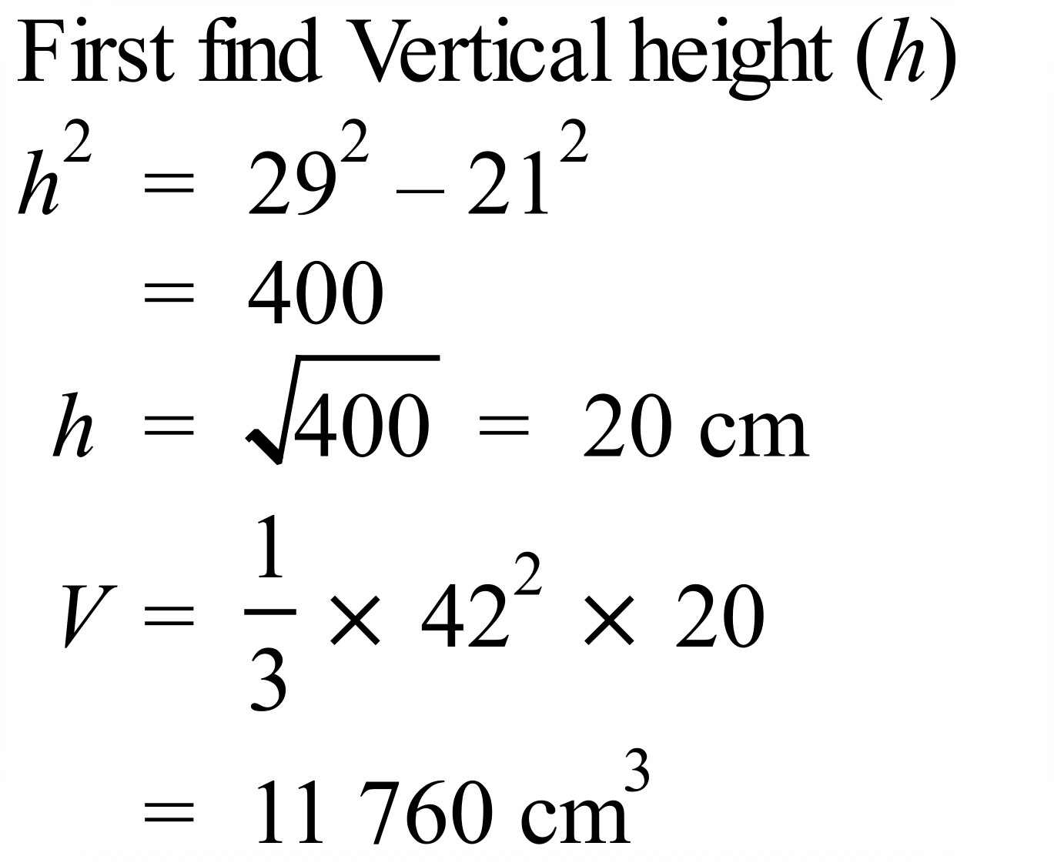 | A
 | 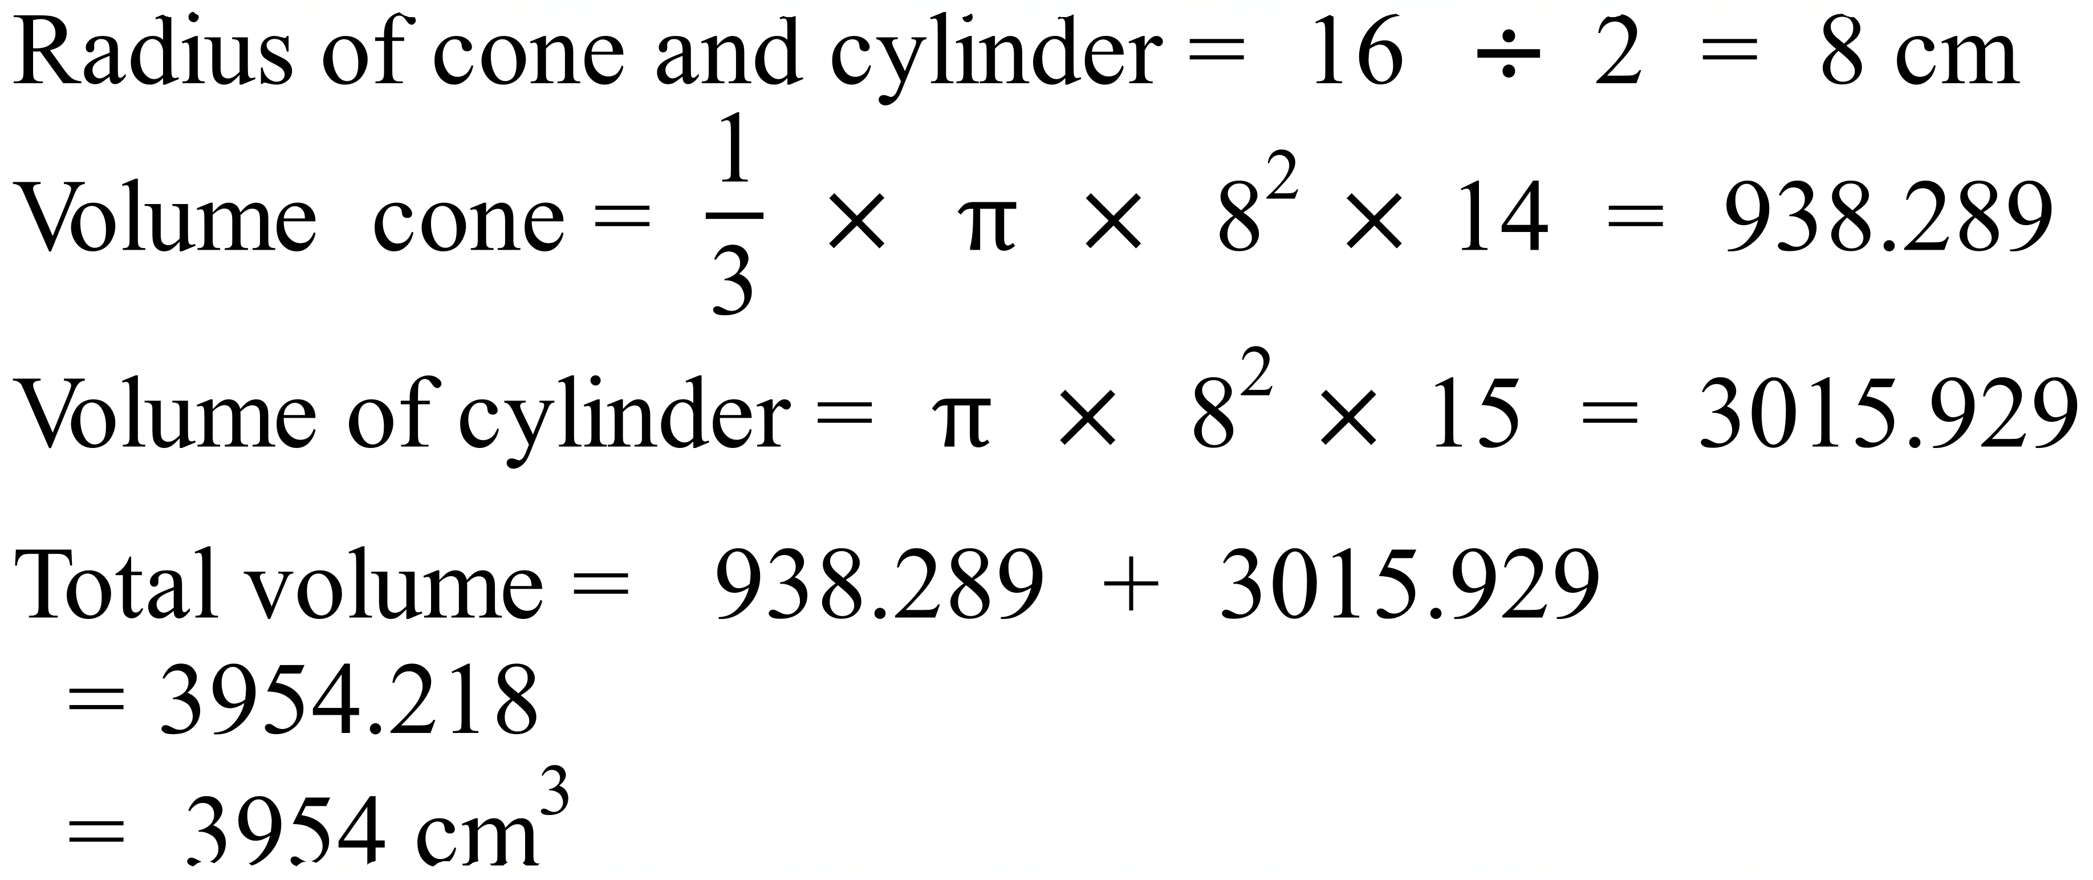 | C
 | 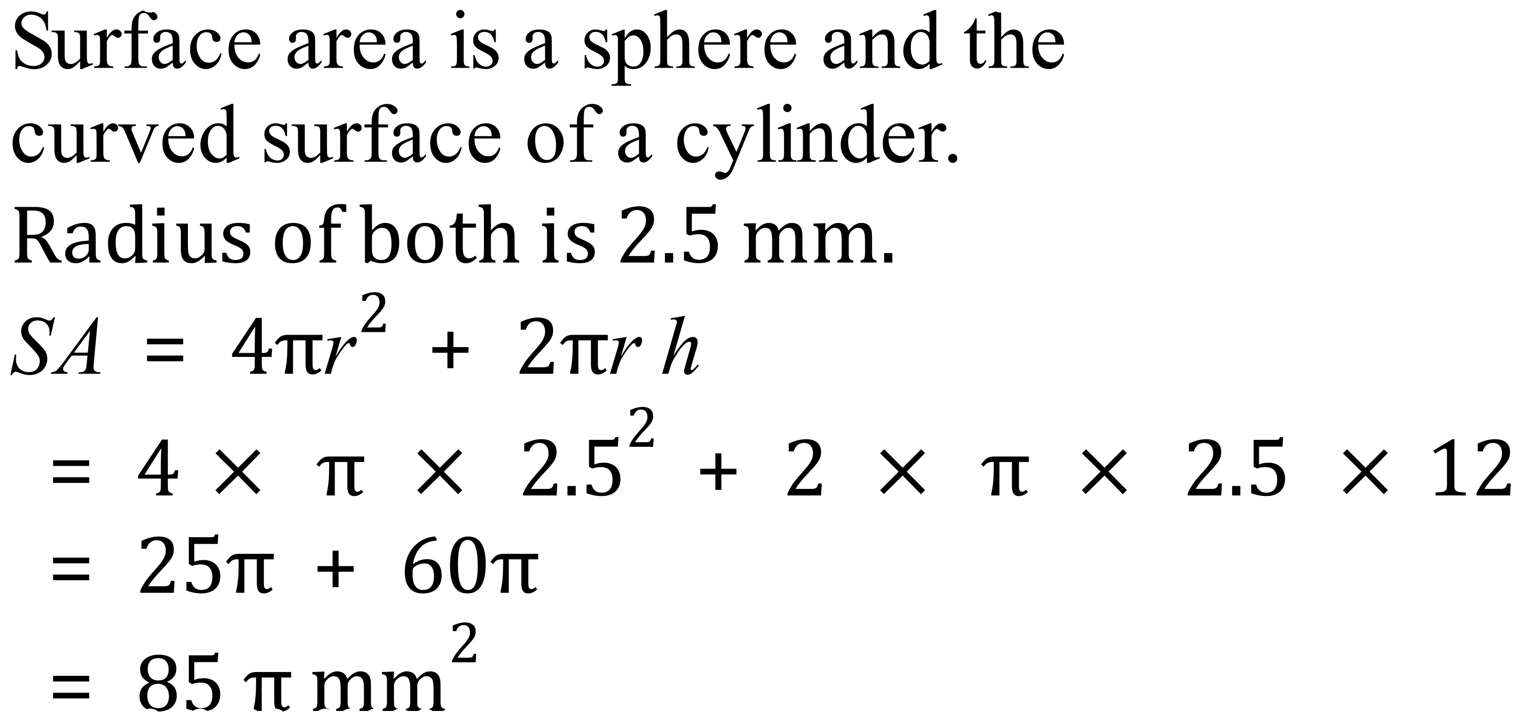 | B

School Name
Mathematics 2017
Multiple Choice Answer Sheet
Volume and Surface Area of Other Solids
Name _____________________________________________
Completely fill the response oval representing the most correct answer.
1. A B C D
2. A B C D
3. A B C D
4. A B C D
5. A B C D
6. A B C D
7. A B C D
8. A B C D
9. A B C D
10. A B C D
11. A B C D
12. A B C D
13. A B C D
14. A B C D
15. A B C D

School Name
Mathematics Test 2017
Year 10 | Volume and Surface Area of Other Solids | Calculator Allowed  Longer Answer  Section
ANSWERS
Question | Working and Answer | Marks
1. | (a)  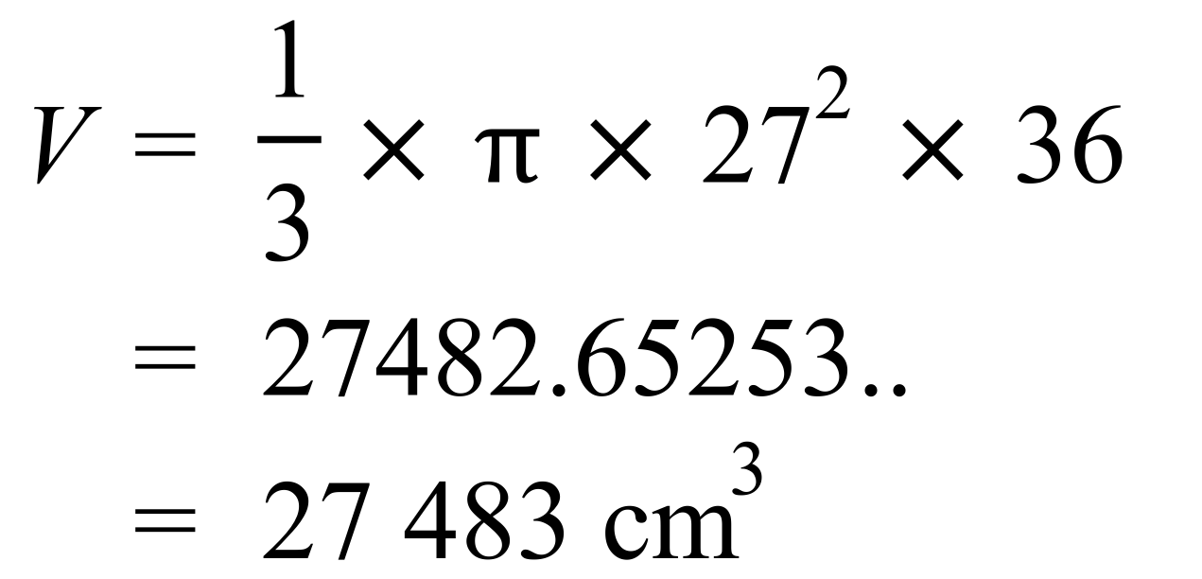 | 1
 | (b)  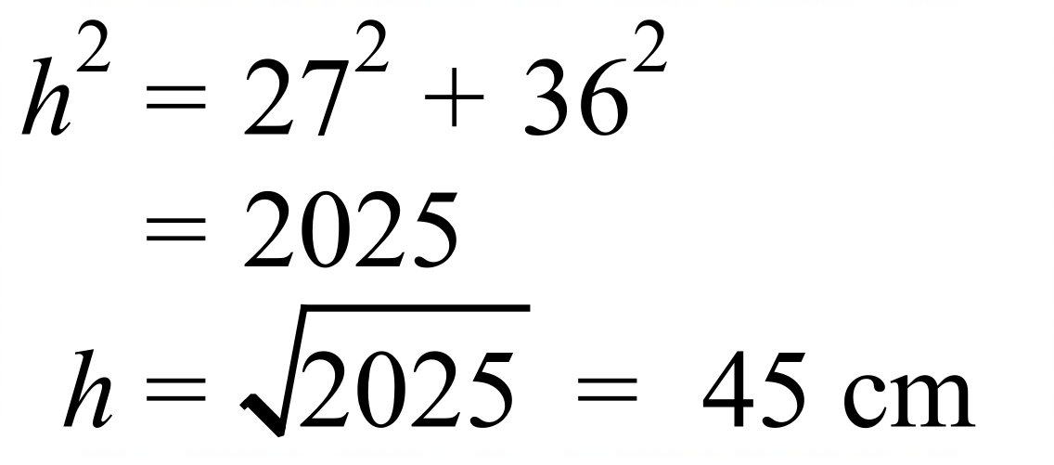 | 1
 | (c)  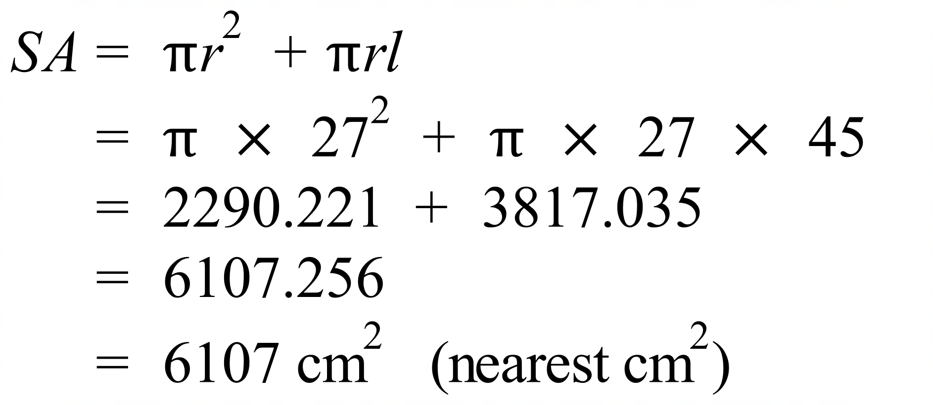 | 2
2. | (a)  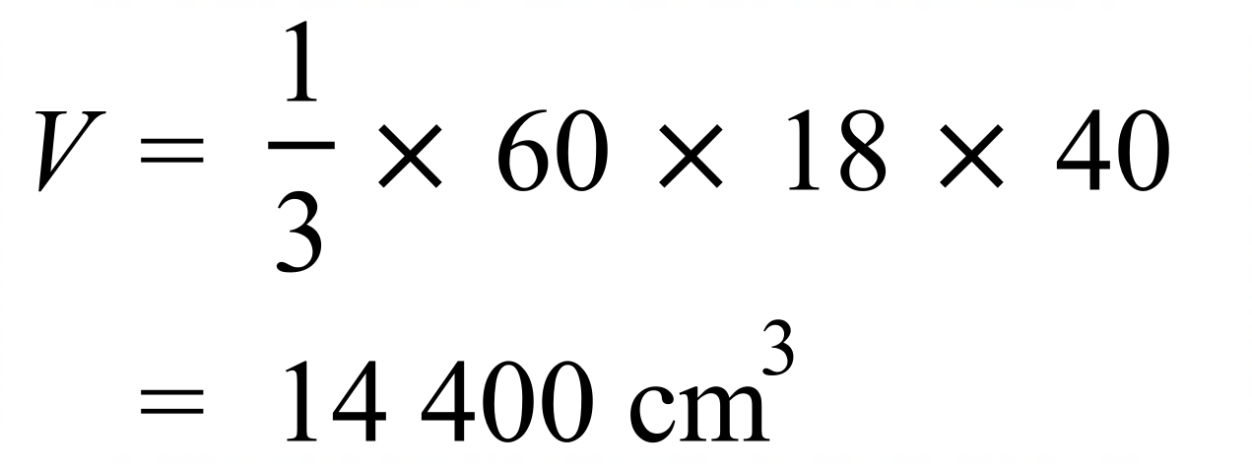 | 1
 | (b)  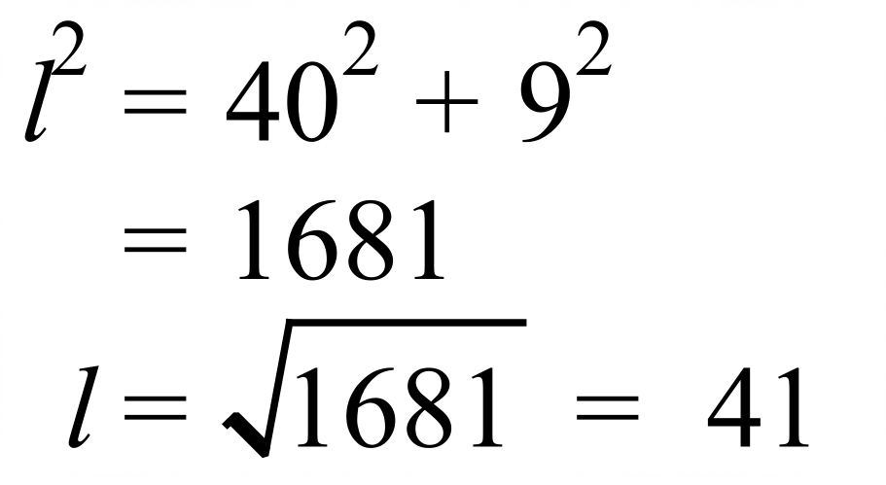 | 1
 | (c) 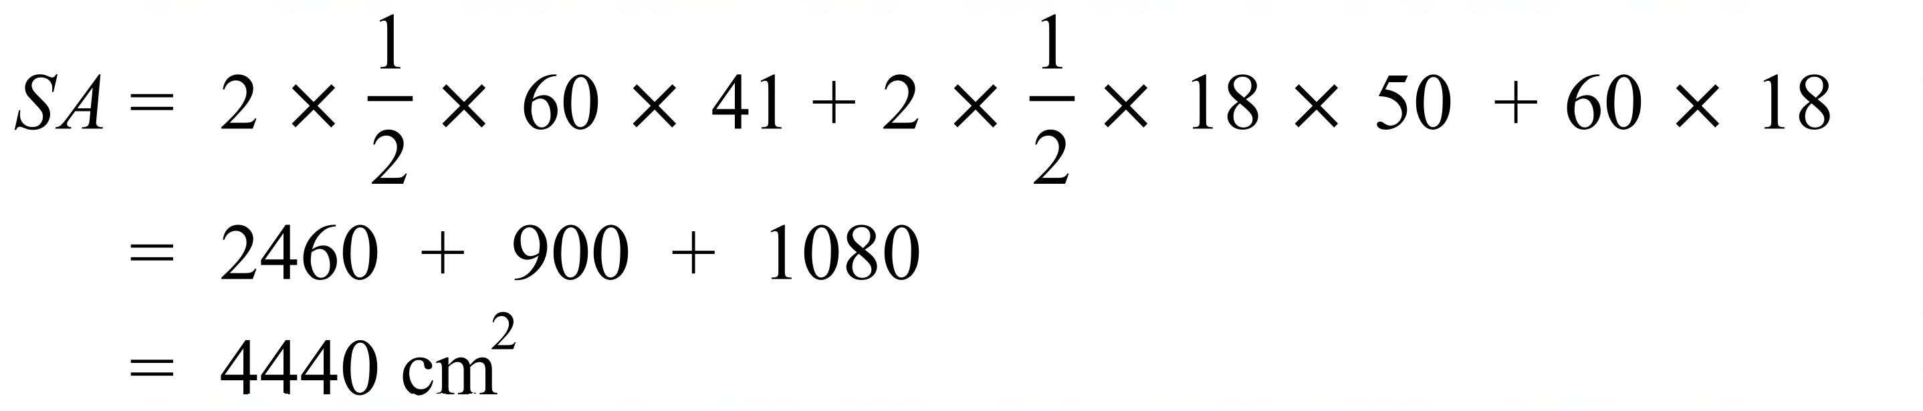 | 2

